OpenText™ Web Experience Management Audit Release Notes
16.0
2016-04-22

Contents
Web Experience Management Audit Release Notes 2
1 Introduction 3
1.1 Release Notes Revision History 3
2 About Web Experience Management Audit 3
2.1 New Features 5
2.1.1 Web Experience Management 16.0 support 5
3 Packaging and Documentation 5
3.1 Packaging and Delivery Information 5
4 Supported Environments and Compatibility 6
4.1 Supported Systems 6
4.2 Compatibility Matrix 7
4.3 Language Support 7
5 Installation and Upgrade Notes 7
5.1 Installation Notes 8
5.2 Upgrade Notes 8
6 Fixed Issues 9
7 Contact Information 11

Introduction
These Release Notes provide an overview of Web Experience Management Audit 16.0, including new features, delivery information, and supported platforms. OpenText recommends that you read these Release Notes in conjunction with the documentation included with the software package. If any conflicts exist, the Release Notes supersede the other documentation.
We also recommend that you check the OpenText Knowledge Center (https://knowledge.opentext.com/) for any patches or documentation updates that may have been posted after the initial release of Web Experience Management Audit 16.0.

Release Notes Revision History
Release Notes Revision Number | Modification Date | Section Modified | Modifications
1.0 | 2016-04-22 | All | Initial release

About Web Experience Management Audit
This section provides an overview of Web Experience Management Audit 16.0.
Web Experience Management Audit 16.0 includes the following new features.
Web Experience Management Audit and Audit Enhanced 16.0 provide views into historical events that allow organizations to track and report system changes to meet their operational, legal, and regulatory compliance requirements. The Web Experience Management Auditing solution is specifically designed to gather information from OpenText Web Experience Management (WEM). The major features of the solution are:
- Gathering of usage information of WEM Management Console and Deployment Agents, including content instances (creation, modification, deletion, publishing, un-publishing), static files, content types, sites and channels.
- Auditing of search operations requested by the user from Web Experience Management Console.
- Gathering of changes made with WEM Configuration Console, including variables added, deleted, and modified, as well as and commit operations.
- Auditing of workflow processes.
- Integrated views into the history of each object registering events within the WEM Management Console.
- Enhanced installer that support Web Experience Management cluster installation.
- Configurable event filter mechanism at origin that allows:
  - Do not register events for some specific users (black list).
  - Disable all events (switch off Web Experience Management Audit)
  - Disable specific events or specific branches of events at Event Tree. (at any level)
  - Disable events for specific Content Types.
  - Disable/enable specific workflows/tasks.
  - Allow any combination of previous filters
- The History button, which allows you to View Details instead of XML applying a XSLT transformation if the corresponding Content Type have that XSLT associated. This feature can be disabled during the configuration.
- OpenText Insights, which is an optional advanced report and analysis application only available with Web Experience Management Audit Enhanced. It provides the ability to run parametric reports across events, users, and time periods:
  - Console help and online help are available in English and Spanish depending on the selected language on the login page.
  - The Admin tab includes:
    - Event model order feature, which allows you to order the event tree to accommodate it to the users preferences
    - Skin editor, which is used to customize OpenText Insights appearance
    - Segments editor, which allows configuring segments that are interesting to produce reports. A segment corresponds to an LDAP group or, for more dynamic segments, a specified query.
  - My Reports functionality:
    - Allows to each user to save their usual reports (only graphic reports, not available for search reports) and organize them into folders.
    - Saved reports can be executed at any time by the user.
    - Saved reports can be scheduled to be executed periodically by the system and send them by email to the specified addresses.
    - Each report can have multiple schedules associated.
    - Each schedule allows multiple options. Specific periods, hours and even cron-like expressions for finer reporting.
    - Reports in Excel or CSV format
  - OpenText Insights provides four different report types that allow you to audit, monitor, and analyze your content management and web site usage data:
    - Evolution: A line chart that lets you see how something progressed through time, e.g. the number of static files created each day or the number of unique website visitors.
    - Top: A bar chart that allows you see the top or the bottom number of occurrences for a given event. For example, type of content instances that were created the most in the past 30 days.
    - Distribution: A pie chart that lets you compare the values of the event occurrences. For example, type of events that are occurring within your content instances and their change rate relative to all events.
    - Search: A listing report of events and the associated details.

The examples above are samples of the reporting capabilities of OpenText Insights and its reporting modules. You can also apply powerful filters that will provide vital information about what is happening through your site.

New Features

Web Experience Management 16.0 support
Web Experience Management Audit 16.0 now includes support for Web Experience Management 16.

Packaging and Documentation
Downloads and documentation for Web Experience Management Audit are available on the OpenText Knowledge Center (https://knowledge.opentext.com/).

Packaging and Delivery Information
The software and documentation for Web Experience Management Audit includes:
- Web Experience Management Audit 16.0 (Install and Configuration Guide)
- Web Experience Management Audit 16.0 (User Guide)

Supported Environments and Compatibility
This section provides details on supported platforms and version information.

Supported Systems
Operating Systems
- IBM AIX 6.1 TL2+
- IBM AIX 7.1
- Sun Microsystems Solaris 10 Update 4+ with 20070207 (or later) Recommended/J2SE Patch Clusters
- Sun Microsystems Solaris 11
- Microsoft Windows® Server 2008 R2 SP1 or later Server Standard and Enterprise Editions
- Microsoft Windows® 7
- Microsoft Windows® Server 2012 and Microsoft Windows® Server 2012 R2
- Novell SuSE Linux Enterprise Server 10 SP1+ and later SPs
- Novell SuSE Linux Enterprise Server 11.x
- Red Hat Enterprise Linux Server release 6.x
- Red Hat Enterprise Linux Server release 7.x
Application Servers
- Runtime Services Integrated Application Server
Database Servers
- Oracle 11g Database Standard and Enterprise 11.2.0.1 and later patch sets of 11.2.0.x
- Oracle RAC: Oracle 11g Database Standard and Enterprise 11.2.0.1 and later patch sets of 11.2.0.x
- Oracle 12c Database Standard and Enterprise
- Oracle RAC: Oracle 12c Database Standard and Enterprise
- Microsoft SQL Server™ 2012 Standard and Enterprise Edition
- Microsoft SQL Server™ 2014 Standard and Enterprise Edition
Directory Servers
- IBM Tivoli Directory Server 6.x
- Microsoft Active Directory for Windows 2008
- Microsoft Active Directory for Windows 2012
- Novell eDirectory 8.8.x
- OpenLDAP 2.3.x and 2.4.x
- Sun Java System Directory Server 6.x
- Oracle Directory Server Enterprise Edition 11g
- OpenDJ Directory Server 2.5.0 Express1 and 3.0
- Runtime Services Integrated LDAP Server
Browsers
- Mozilla Firefox 44.0
- Microsoft Internet Explorer 10.0
- Microsoft Internet Explorer 11.0
- Google Chrome 48.0
- Apple Safari 9

Compatibility Matrix
For details on compatibility between OpenText products, refer to the Compatibility Matrix (https://knowledge.opentext.com/knowledge/llisapi.dll/open/15507401) in the OpenText Knowledge Center.

Language Support
Web Experience Management Audit is currently localized in the following languages. Future releases may add additional languages.
Component | Languages
Component | EN | DE | JA | FR | IT | ZH | ES | RU
WEM Audit Tab | B |  |  |  |  |  | UI
Insights console | B |  |  |  |  |  | B
UI = user interface only
B = both user interface and online help

Installation and Upgrade Notes
This section provides additional installation and upgrade information, including related or third party product information and any required critical patches.

Installation Notes
Before you install Web Experience Management Audit, review these additional installation notes and verify related product or third party product requirements.
For information on how to install and configure the product, see OpenText Web Experience Management Audit 16.0 Installation and Configuration Guide.

Upgrade Notes
If you are going to upgrade Web Experience Management Audit 10.5.0 (or older) to version 16.0, and you are using OpenText Directory Services for Audit authentication, take in consideration that now Audit uses OTDS Groups instead of OTDS Access Roles for role mapping in RTB.
Before the upgrade, you must map the OTDS Groups to the RTB roles. You can perform those steps on the OpenText Insights Admin tab. This is a mandatory to be able to have access to OpenText Insights after the upgrade.
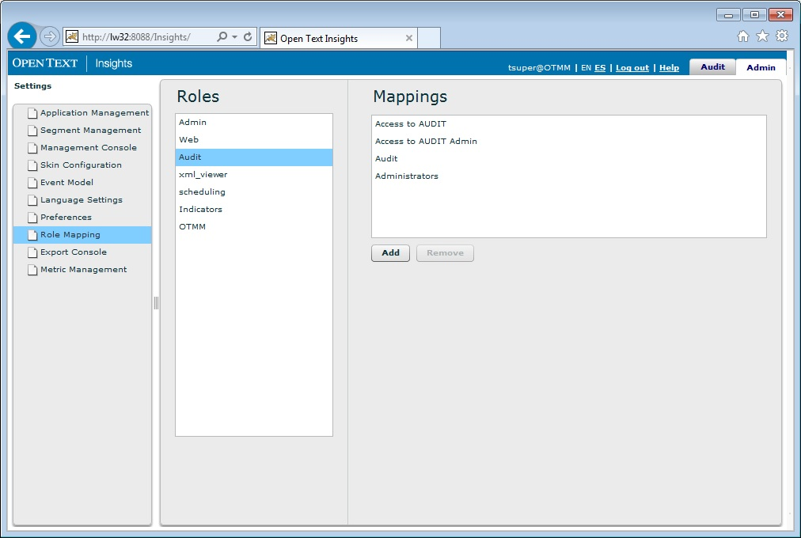
To perform the upgrade, do the following:
- Open the OpenText Insights console, login with a user with administration privileges and navigate to the Admin tab.
- Navigate to the Role Mapping section and provide OTDS Groups for each one of the roles, accordingly to your needs.
Tip: Use 2 different groups: one for user access and another one for administration purposes. If you are using 2 Access Roles for that, you just need now to use Groups instead of Access Roles.
- Perform the upgrade as described in the OpenText Web Experience Management Audit 16.0 Installation and Configuration guide.
- You can delete the Access Roles mapped to the RTB roles after the upgrade.
If you wish to continue using Access Roles in order to map the RTB roles and categorize the users after the upgrade, you can use the option auth_groups=disabled in the table TBRTB_PROPERTIES. You can use the following script to update it:
INSERT INTO tbrtb_properties (propkey,propvalue)
VALUES('auth_groups','disabled');

Fixed Issues
This section provides information about past issues that have been fixed in this release.
Issue Name | Issue Description
Error with the installer when using multiple disk drives on Windows | Reported problem related to the installation process on Windows when performing an installation where the installation folder is in a different disk drive of the installer folder, giving the error: Error obtaining DataSource for DB connection pool:null.
Error upgrading WEM Audit performing getVCMInstaceName | Reported problem when upgrading WEM Audit in the step where the installer gets the VCM Instance Name. Fails with a NullPointerException error.
OTDS 10.5 SP1 Patch 5 compatibility problems | Reported problems accessing Insights console when using OpenText Directory Services 10.5 since patch 5. Could not obtain the groups of the user.
OTDS support in RTB Loader | The RTB Loader utility now works with OTDS instead of LDAP, if you specify the parameter –otdsFile instead of the parameter –ldapFile. You must use one of them, and never both.
RTB Loader continue without groups | Fixed a bug that blocked the RTB Loader utility from being executed without segmentation groups.
Missing json.jar in installer classpath | Fixed the missing json.jar reference in the installer classpath.

Contact Information
OpenText Corporation
275 Frank Tompa Drive
Waterloo, Ontario
Canada, N2L 0A1

Support: https://support.opentext.com

Knowledge Center: https://knowledge.opentext.com

For more information, visit www.opentext.com

