OpenText™ Web Experience Management Audit
User Guide
16.0
Product Released: 2016-07-21

OpenText™ Web Experience Management Audit
User Guide
Rev.: 2016-Jul-21

This documentation has been created for software version 16.0.
It is also valid for subsequent software versions as long as no new document version is shipped with the product or is
published at https://knowledge.opentext.com.

Open Text SA
40 Avenue Monterey , Luxembourg, Luxembourg L-2163
Tel: 35 2 264566 1

Open Text Corporation
275 Frank Tompa Drive, Waterloo, Ontario, Canada, N2L 0A1
Tel: +1-519-888-7111
Toll Free Canada/USA: 1-800-499-6544 International: +800-4996-5440
Fax: +1-519-888-0677
Support: http://support.opentext.com
For more information, visit https://www.opentext.com

Copyright © 2016 Open Text SA or Open Text ULC (in Canada). All Rights Reserved.
Trademarks owned by Open Text SA or Open Text ULC (in Canada). All rights reserved.

Disclaimer
No Warranties and Limitation of Liability
Every effort has been made to ensure the accuracy of the features and techniques presented in this publication. However,
Open Text Corporation and its affiliates accept no responsibility and offer no warranty whether expressed or implied, for the
accuracy of this publication.

Contents
OpenText™ Web Experience Management Audit User Guide 2
1 Introduction 4
1.1 User Guide Revision History 4
2 Event history on Content Workspace 5
3 OpenText Insights 7
3.1 Browser Requirements 8
4 OpenText Insights User Guide 9
4.1 Accessing OpenText Insights 9
4.2 Getting Started 10
4.3 Real-time User Event reports 11
4.3.1 Email results 13
4.3.2 Print results 14
4.3.3 Export results 14
4.4 Saved Reports 15
4.4.1 Schedule a report 16
5 Contact Information 17

Introduction
This user guide provides information about features and functionality of Web Experience Management Audit 16.0. OpenText recommends that you read this user guide along with the documentation included with the software package.
We also recommend that you check the OpenText Knowledge Center (https://knowledge.opentext.com/) for any documentation updates that may have been posted after the initial release of Web Experience Management Audit 16.0.

User Guide Revision History
User Guide Revision Number | Modification Date | Section Modified | Modifications
1.0 | 2016-07-22 | All | Initial release

Event history on Content Workspace
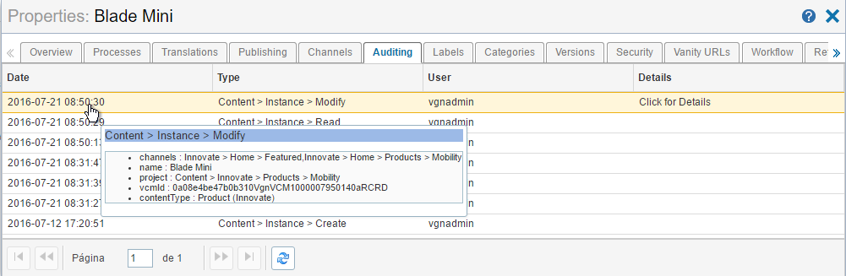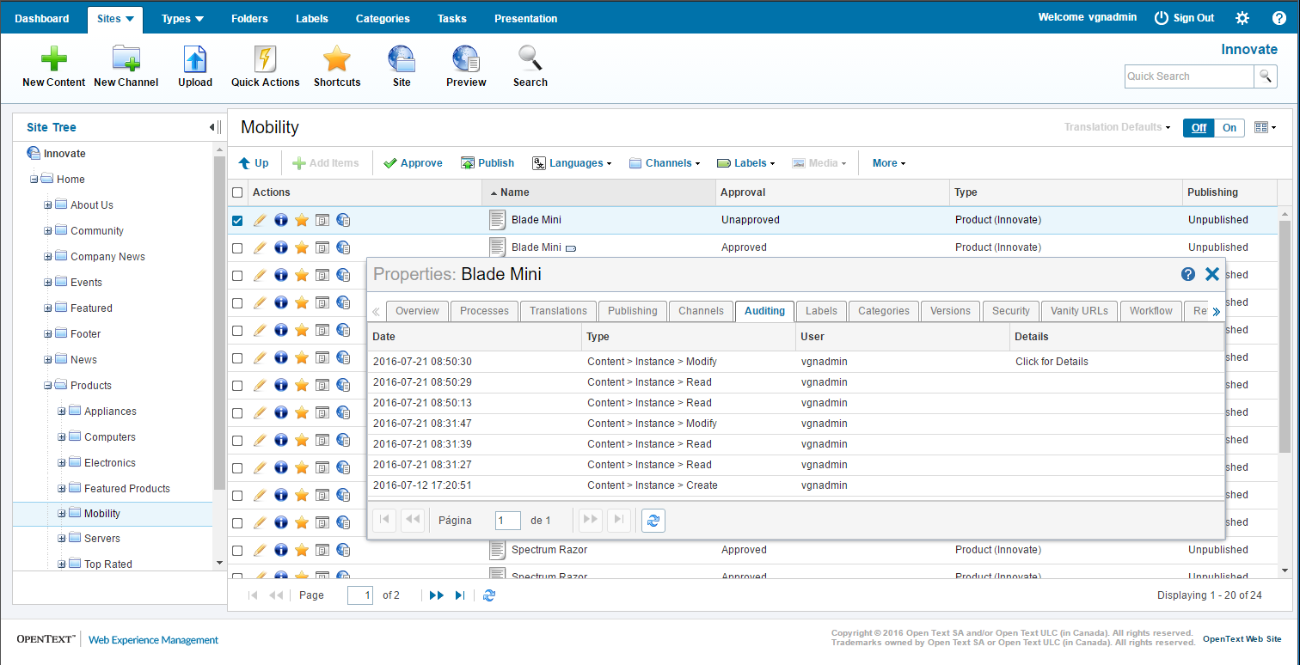Web Experience Management Audit contains Content Workspaces extensions that will allow you to view event history directly in Content Workspaces. The Auditing tab appears in the Properties window of any content item in Content Workspace and displays the events related to that content.

The Auditing tab displays the list of events associated with the content organized by date. For each event, you can see its date and the user who performed it. If you place the pointer over the Date column, you can see more information about that event.

If you enable the XML reporting, the Click for Details link appears in the Details column. Use this link to generate CREATE and MODIFY events for content items that you want to audit. For more information on how to enable the XML reporting, see the Web Experience Management Audit Install and Configuration Guide.
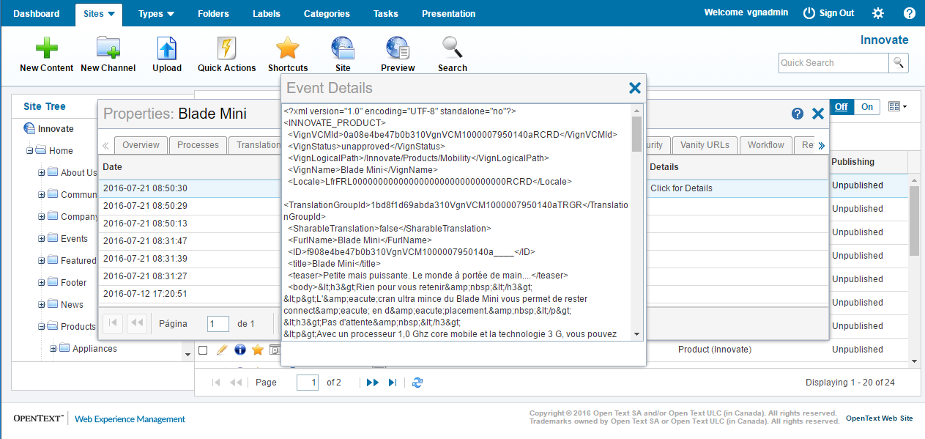Every CREATE or MODIFY event generates an entry in the Event Details log.

OpenText Insights
OpenText Insights is an optional real-time reporting console built on top of a flexible and extendable monitoring platform, which allows you to view the WEM Audit events and create complex reports within Web Experience Management system.
OpenText Insights provides four different report types for auditing, monitoring, and analyzing your content management data:
- Evolution: A line chart that lets you see how something progressed through time, e.g. How many static files are created per month?
- Top: A bar chart that lets you see the top or bottom number of occurrences for a given event, e.g. What type of content instances were created the most in the past 30 days?
- Distribution: A pie chart that lets you compare the values of the event occurrence, e.g. What are the most used content types their relative usage as compared to all other?
- Search: A simple list of events and their associated details.
The examples mentioned above represent the sample of the reporting capabilities of OpenText Insights and its reporting modules. In addition to those, you can apply powerful filters that will provide you with vital information about what is happening through your site or audited application.
After you create a report, you can print the report as a multi-page document with all details, or you can download it as XLS (Excel) or CSV (comma-separated values) files. You can also email the report file for further analysis, or save the report configuration in your Insights console and have the results emailed to you periodically.

Browser Requirements
You must install Adobe Flash Player 9 (or above) and enable JavaScript cookies to run the OpenText Insights. The OpenText Insights console supports Google Chrome, Firefox, Opera, and Internet Explorer.
 |  |  | Important  - OpenText recommends to only open one Insights console at the time. Opening more than one console at the time is not supported.  - If you run the Insights console in Firefox for extended periods of time (hours), Firefox will start occupying a significant amount of memory, which may reduce system performance. If this happens, restart Firefox.

OpenText Insights User Guide
This section provides instructions about using the OpenText Insights console.

Accessing OpenText Insights
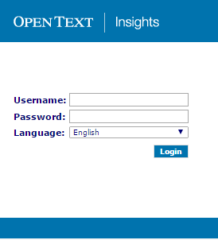OpenText Insights is available at http://host:port/Insights, where host and port are related to the Web Experience Management server. You will need credentials to access OpenText Insights. In a default installation set up, use the same credentials you use to access Web Experience Management.

Getting Started
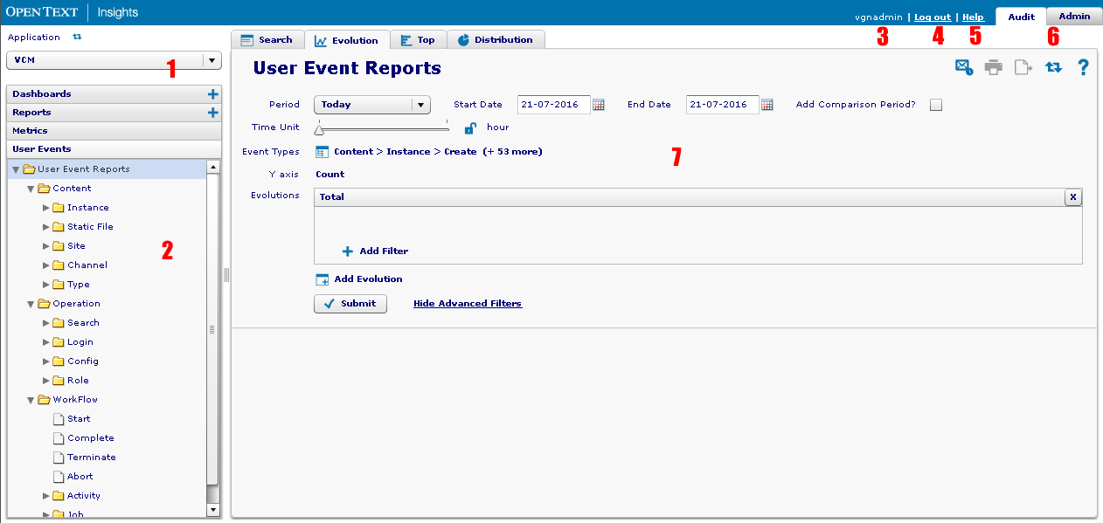
The following figure provides the illustration of OpenText Insights console.

The OpenText Insights console has the following common sections for all operations in the console:
- Application: Switch between different Auditing applications/environments.
- Events tree: From this tree you can see all audited events and select which event (or category/folder) you want to view in your searches.
- Logged in user: The current user logged in the system.
- Logout: Logout from the OpenText Insights console.
- Help: Link to the online help. The context-sensitive help provides specific information about whatever part of the console you are at any given moment.
- Tabs: Navigate between different reporting modules, accordingly to your permissions. In the case of Web Experience Management Audit, there are only 2 tabs:
  - Audit tab for auditing and reporting purposes.
  - Admin tab for OpenText Insights administration and configuration purposes.
- Reporting area: This is the area where you will see search properties, results, and your reports.

Real-time User Event reports
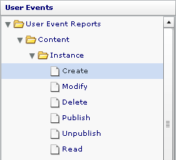
Selecting an event (or a category/folder of events) from the Events tree allow you to quickly generate a report on the events that you selected.

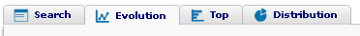
You can choose different report types from the tabs at the top of the reporting area.

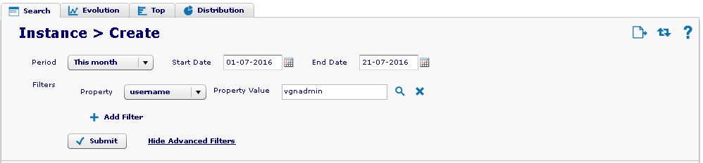
You can filter your search by time period and other filters. The filter options depend on the events you selected and they represent the properties of the events. If you select multiple events, only the common properties between all those events will be available for filtering.

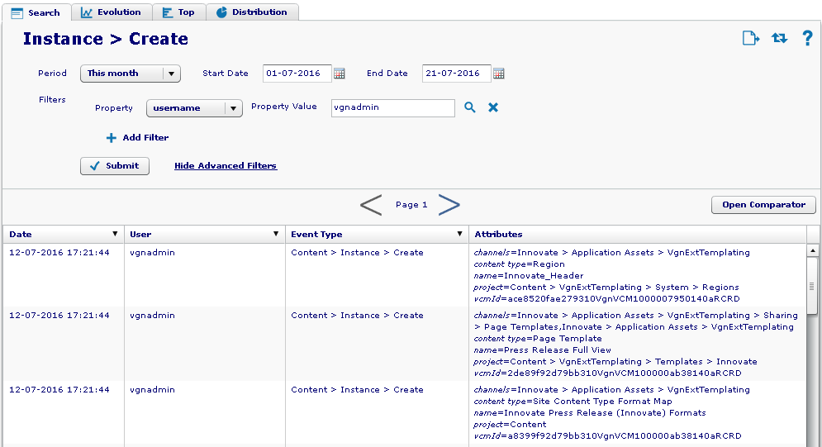
When you click Submit, the search results pane opens. The following figures illustrate the sample search and filter results.
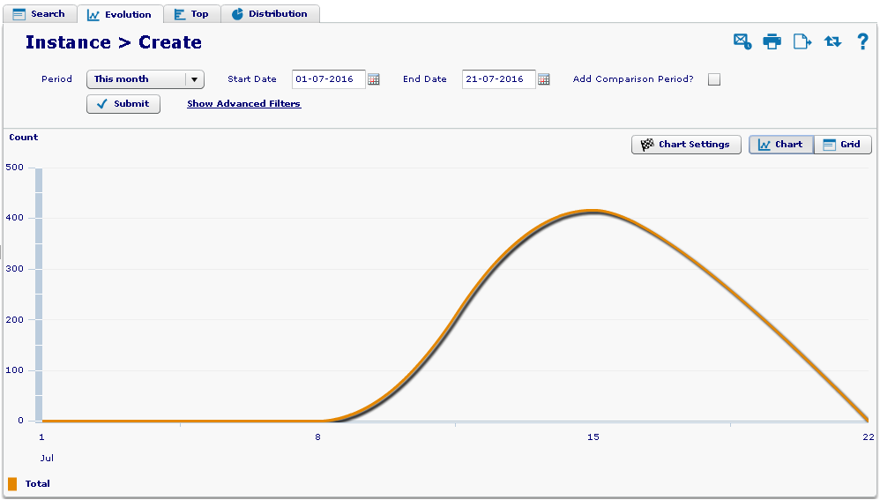

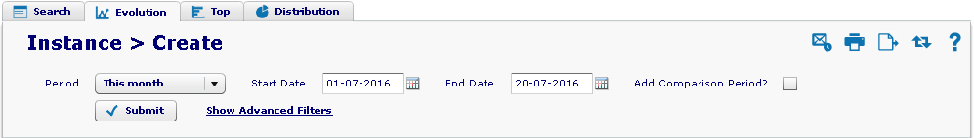
You can use the tools at the top right corner of the window to perform common actions, such as Email, Print and Export the results.

Email results
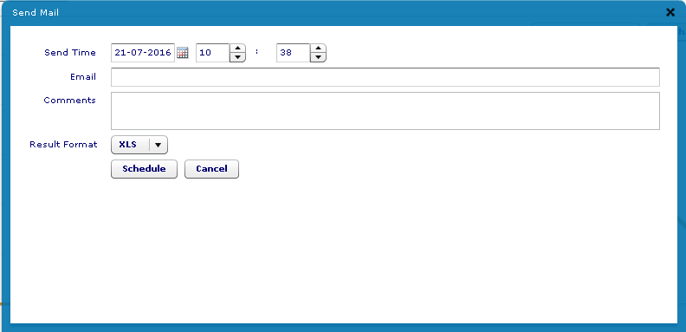
The figure below illustrates an email notification that you can use to schedule when to send the report results.

The email notifications are not automatically generated every time a report is created. You must set up the schedule that will periodically send email notifications. For more information, see the Web Experience Management Audit Install and Configuration Guide.

Print results
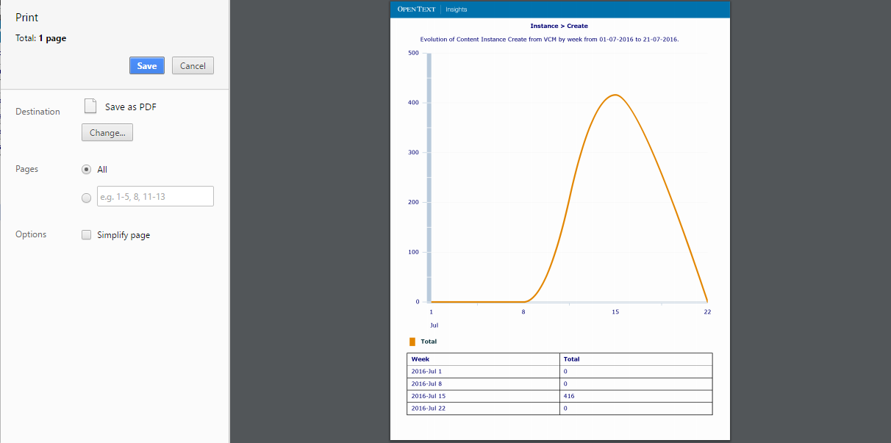
You can print your results directly from the browser.

Export results
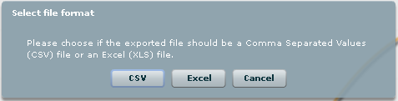
You can export your results to a file on your computer. You can export in 2 formats, CSV or Excel.

Saved Reports
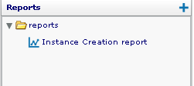
Use the Reports area in the menu to create and save reports. These reports are like any other real-time search and allow you to execute reports when you need.
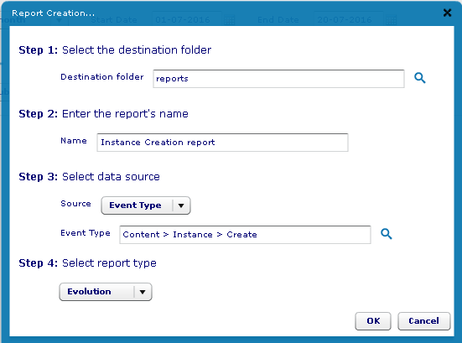
Click the Add icon to create a new report. Select the Insights folder where you want to save your report, provide a name, select which events the report refers to, and choose a report type. Click OK to create the report.

A report is like any other search, which you can save to run when you need it. Ensure that every time you change any of the filters, you save your report.

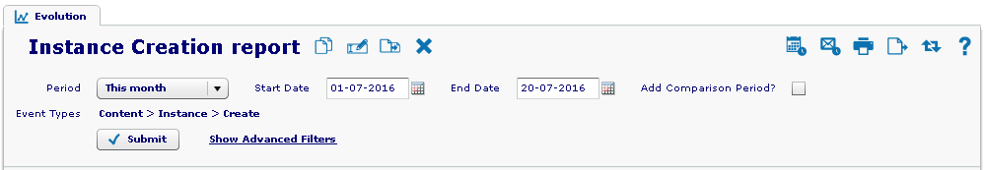
You can use the tools at the top right corner of the window to perform common actions, such as Email, Print, Export, and Schedule the results.

The real-time reports only use actions to Email, Print, and Export the results.

Schedule a report
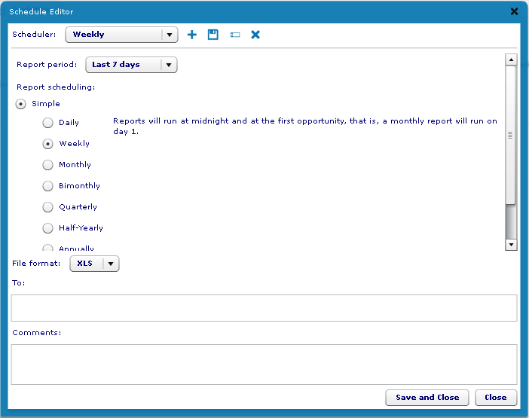
Scheduling a report allows you to set a time frame when the report will be executed and when the results will be emailed. For example, you can generate a report once a week, and then schedule a date for the results to be emailed. You create a scheduler where you set when the report will be executed, and the time period for the results (you can set a time period different from the time period saved on the report). The automatic process will generate the report for the time period of your choice according to the scheduler that you have configured.

Contact Information
OpenText Corporation
275 Frank Tompa Drive
Waterloo, Ontario
Canada, N2L 0A1

Support: https://support.opentext.com

Knowledge Center: https://knowledge.opentext.com

For more information, visit www.opentext.com

