

Web Experience Management Audit

User Guide

Version 10.5

OpenText Web Experience Management Audit
User Guide
Rev.: 2015-January-07

This documentation has been created for software version 10.5.
It is also valid for subsequent software versions as long as no new document version is shipped with the product or is published at https://knowledge.opentext.com .

OpenText SA

40 Avenue Monterey , Luxembourg, Luxembourg L-2163

Tel: 35 2 264566 1

OpenText Corporation

275 Frank Tompa Drive, Waterloo, Ontario, Canada, N2L 0A1

Tel: +1-519-888-7111
Toll Free Canada/USA: 1-800-499-6544 International: +800-4996-5440
Fax: +1-519-888-0677
Email: support@opentext.com
FTP: ftp://ftp.opentext.com
For more information, visit http://www.opentext.com

Copyright © 2013 by OpenText Corporation

OpenText is a trademark or registered trademark of OpenText SA and/or OpenText ULC. The list of trademarks is not exhaustive of other trademarks, registered trademarks, product names, company names, brands and service names mentioned herein are property of OpenText SA or other respective owners.

Disclaimer

No Warranties and Limitation of Liability
Every effort has been made to ensure the accuracy of the features and techniques presented in this publication. However, OpenText Corporation and its affiliates accept no responsibility and offer no warranty whether expressed or implied, for the accuracy of this publication.

Contents

1 Introduction 5
1.1 User Guide Revision History 5
Topic 5
Modifications 5
Revision Number 5
2 About Web Experience Management Audit 6
2.1 Introduction 6
2.2 Accessing event history from Content Workspaces 6
2.3 Event History functionality 7
3 Introduction to OpenText Insights 10
3.1 About OpenText Insights 10
3.2 What can OpenText Insights do for you? 10
3.3 Browser Requirements 12
4 Getting Started 13
4.1 OpenText Insights Console Overview 13
4.2 Accessing the OpenText Insights Console 13
4.3 Getting Started 13
5 How-To’s 16
5.1 Access On-line Help from a Pop Up 16
5.2 Generate a Report 17
5.3 Export a Report 17
5.4 Print a Report 19
5.5 Email a Report 20
5.6 Make a Report with Two Different Event Types 21
5.7 Make an Evolution with Two Lines 23
6 Contact Information 25

Introduction
This User Guide provides a Web Experience Management Audit version 10.5 help to those who start working with the tool for the first time. OpenText recommends that you read this User Guide in conjunction with the documentation included with the software package.

We also recommend that you check the OpenText Knowledge Center (https://knowledge.opentext.com/) for any patches or documentation updates that may have been posted after the initial release of Web Experience Management Audit version 10.5.

User Guide Revision History
Topic | Modifications | Revision Number
All | Initial release | 10.5

About Web Experience Management Audit
This section provides an overview of Web Experience Management Audit version 10.5.

Introduction
The version 10.5 of Web Experience Management Audit solution provides users the ability to access the History Button of WEM objects from within Web Experience Management Content Workspaces (see 2.2) and Web Experience Management Management Console (see figure 2).

Web Experience Management Audit allows the users to see the complete event history for any Site, Channel, Content Instance, Static File, Content Type Definition, Workflow definition, Role or Capability. The event history can be configured to also provide to users with a view of the XML details for content creation and modification events.

Accessing event history from Content Workspaces
From Content Workspaces, you can access the history of any Site, Channel, Content Instance or Static File using the “Auditing” tab in the properties window of each object like you can see in the figure below.

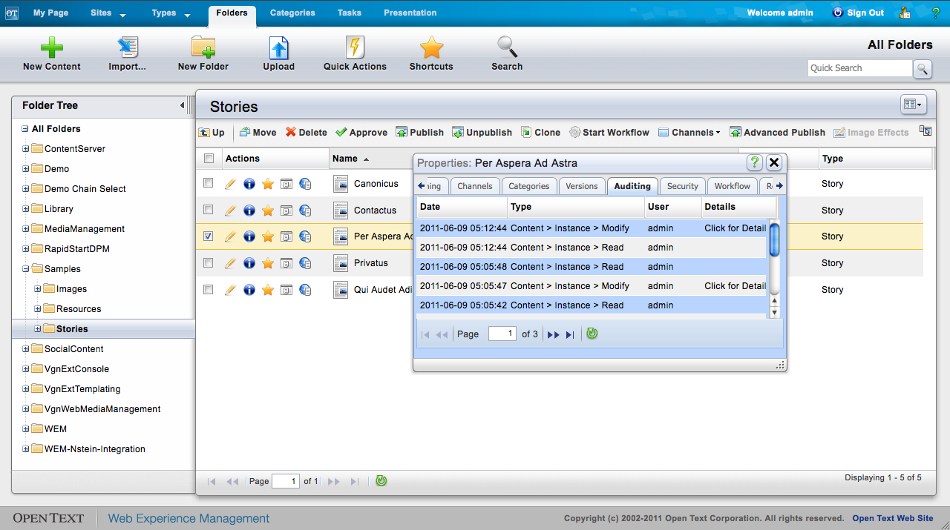
Figure 1 – Auditing tab in the properties window of a content item within Content Workspaces.

The history of Content Type Definitions, Workflow definitions, Roles and Capabilities can only be accessed using the Management Console (see the following section).

Event History functionality
Regardless of the console you are using, you will only get access to the audit functionalities if you are a member of any group authorized to use this particular WEM object.

The event history view displays a list of events associated with the WEM object that you are auditing, ordered by date (latest events first).

For each event, you get date, the event type and the user who performed the action.
When you move the mouse over the date of each event, you will be able to see a tooltip with more details about the event, depending on the WEM object selected you can see properties as: name, content type, project, WEM identifier, etc…
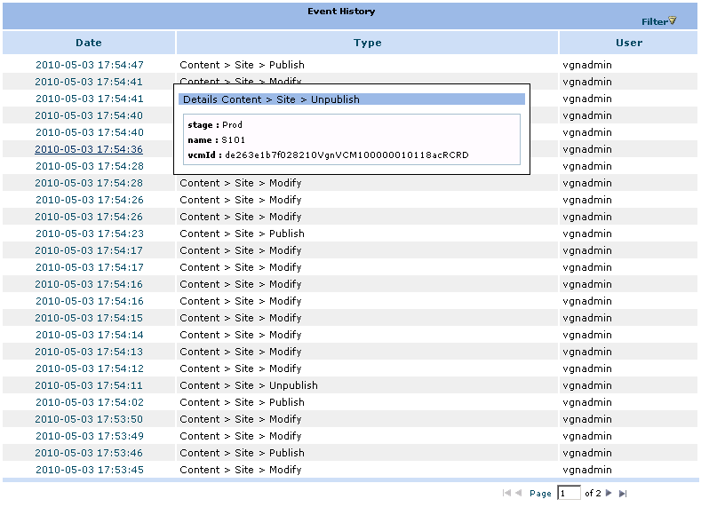
Figure 5 - History of a Site

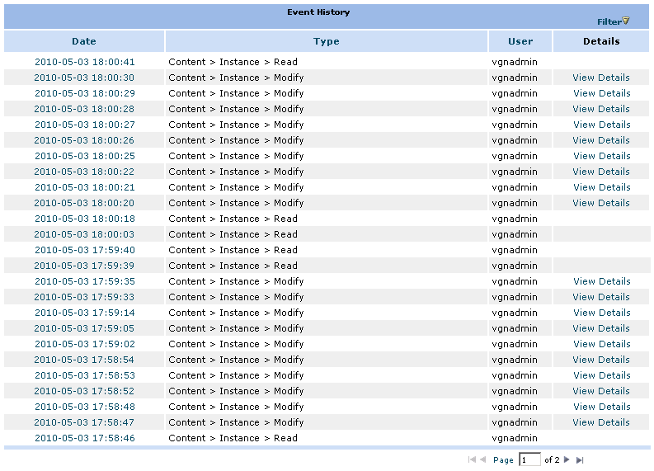
Figure 6 - History of a Content Instance
When a Content Instance is created or modified, the XML with the details of the modification can be seen by clicking “View Details”. Please see the Web Experience Management Audit Installation and Configuration Guide for additional information to enable the ‘View Detail’ link to the XML.

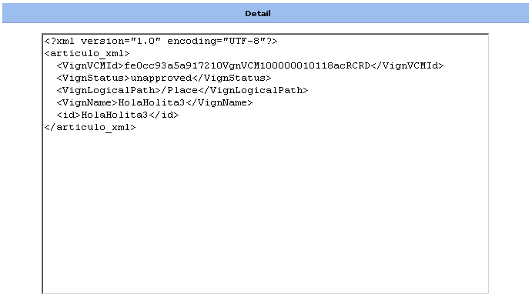
Figure 7 - Details of a Content Instance Modification

Additionally, if the content instance has a XSL preview template associated, and the installation of WEM Audit is properly configured, the details page can display – instead of the raw XML information – the HTML page obtained by applying the XSL to the XML associated with the event.

Introduction to OpenText Insights
This is the User Guide for OpenText Insights Console and its reporting modules. This User Guide will show you how to use the OpenText Insights Console to create, manage, email, print and export Insights reports.

About OpenText Insights
OpenText Insights is a real-time reporting console built on top of a flexible and extendable monitoring platform that allows your organization to register content management and website visitor events connected to specific actions that your organization deems relevant and would like the ability to report on.

What can OpenText Insights do for you?
OpenText Insights provides you with the capability to plug-in optional auditing and web site analytics modules to generate a variety of reports about changes that occur within the Web Experience Management system as well as visitor actions and behaviors of your websites.

OpenText Insights provides four different report types that allow you to audit, monitor and analyze your content management and web site usage data:

- Evolution: A line chart that lets you see how something progressed through time, e.g. How many static files are created per month? or Which is the number of unique website visitors each day?
- Top: A bar chart that lets you see the top or bottom number of occurrences for a given event, e.g. What type of content instances were created the most in the past 30 days?
- Distribution: A pie chart that lets you compare the values of the event occurrence, e.g. What are the most viewed website pages and their relative usage as compared to all other web page visits?
- Search: A lists report of events and their associate details.
The examples above are a small example of the reporting capabilities of OpenText Insights and its reporting modules. You can apply powerful filters that will provide you with vital information about what is happening through your site or audited application.

You can do more with the OpenText Insights Console than just create reports. After you create a report you can print the report to a multi-page document that contains all the information in the report. Or you can download it as an XLS (Excel) or CSV (comma-separated values) file. You can also email the report file to someone for further analysis. You can even save a report's configuration in your management console and have the results sent to you periodically by email.

Besides, the platform includes a powerful API that can be used to develop 'interceptor classes'. These classes can be used to decide on-the-fly if a particular event must be modified or ignored before it is stored in the database. For example using interceptors, it can be implemented a simple solution that discards content instance modification events if for example they have been generated for a particular user.

With all this, you will find OpenText Insights a powerful tool that allows you to turn the information your site or audited application generates into important inputs for your operational decision processes of maintaining and improving your business model.

Browser Requirements
To work properly, the Insights Console requires Adobe Flash Player 9 installed, JavaScript and cookies must be enabled. The Insight Console supports Firefox 2 and above, Opera 9.62 and above, and IE 6 and above.

Important:
- Do not open more than one Insights Console at the same time! Opening more than one console at the same time will lead to unsupported behaviors.
- Firefox is known to have memory leaks while running a Flash Player. If you run the Insights Console in Firefox for extended periods of time (hours), Firefox will start occupying a significant amount of memory which may reduce system performance. In this case, it is recommended that you restart Firefox.

Getting Started
This section provides assistance and Instruction about using OpenText Insights.

OpenText Insights Console Overview
The OpenText Insights Console is a web application that is used to interact with multiple OpenText reporting applications including Web Experience Management Audit Enhanced and a web reporting solution.

Accessing the OpenText Insights Console
To access OpenText Insights Console, open a browser and go to http://host:port/Insights, where host and port have the value of the server where the Web Experience Management is installed. When you do so, you will see the login page:
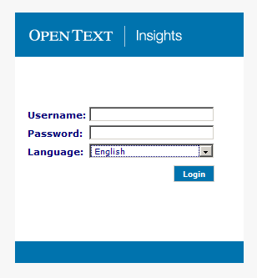
Enter your OpenText Insights username, password and choose the console's language. Click the "Login" button to proceed with the authentication.

Getting Started
After the login the console will open. It should take a couple of seconds for it to load. After it loads you should see the following:
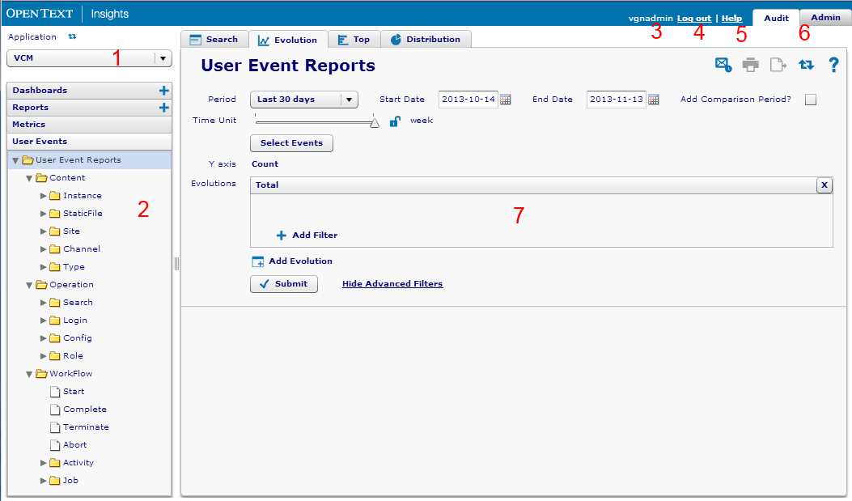
Each item listed below is a description of the major features of the OpenText Insights Console.
- Application Drop-Down Box: This drop-down box allows you to select the application environment you will generate reports from.
- Event Tree: Use this tree to select the type of event you want to report on. Please note that the list of events is specific to the current module selected in the Tabs area. The Audit module event tree contains three main sections:
Content: This section holds reports about the creation, modification, deleting, and publishing of content instances, static files, sites channel, content types, etc.
Operations: This section has information about searches performed in the Web Experience Management Console, activity in the Web Experience Management Configuration Console, Roles, Capabilities, etc.
Workflow: Process started events, complete events, workflow activities, etc.
- User: The name of the currently logged in user.
- Logout: Clicking the Logout link will log you out of the OpenText Insights Console and send you back to the login page.
- Help: Opens the on-line help system.
- Tabs: Allow access to the specific reporting functions within the OpenText Insights Modules you have permission to see.
- Reporting Area: This is the area where you create and view reports. The contents of this area changes based on the active Insights Tab you are viewing and which Event Tree node is selected.

How-To’s
This section contains a series of quick ‘how to’ explanations about the most common reporting actions.

Access On-line Help from a Pop Up
Position the mouse over the pop up. Access the context menu by clicking your mouse’s right click button. Then select the “Help” option from the menu.
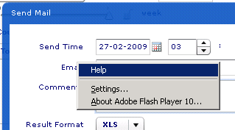

Generate a Report
From within the Events Area (left pane) click on the listed event type you wish to report on:
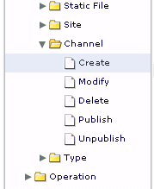

Select the desired report type.
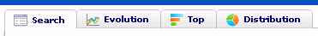

Select the time frame you want to report on.
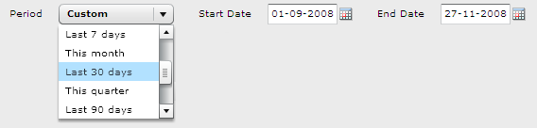

Click the submit button.

Export a Report
Generate the desired report (See 2.).

Click the export button.

Select the file format you want the report to be exported to.
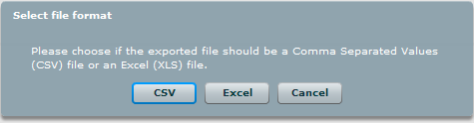

Save the file (Note: the "Save" dialog box is browser-specific).
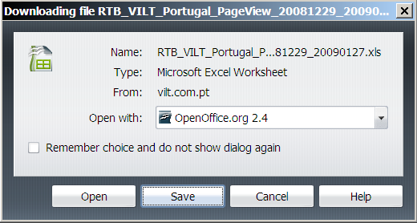

Print a Report
Generate the desired report (See 2.).

Click the print button (not available for Search type reports).

Print the document (Note: the Print dialog is operating system specific).
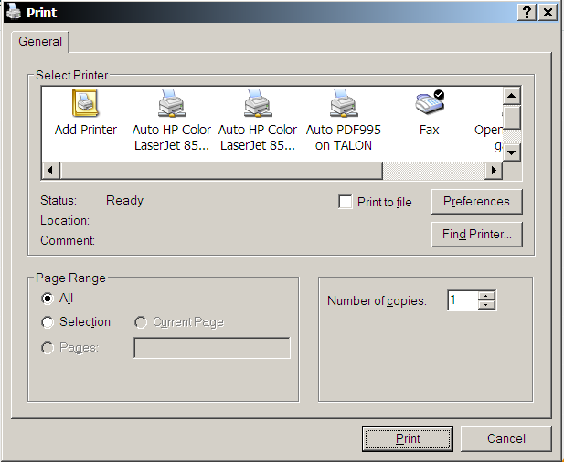

Email a Report
Generate the desired report (See 2.).

Click the send mail button (not available for Search type reports).

Enter the scheduled date and time you want the email to be sent.
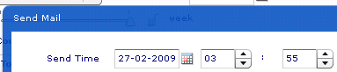

Enter the recipients email address (note: you can only email to a single email address).

Select the file format for the report that will be attached in the email.

Click the schedule button.

Make a Report with Two Different Event Types
Select "User Event Reports" from the event tree.

Select the desired report type.

Click the event selector button.
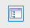
Select the desired event types and press OK.
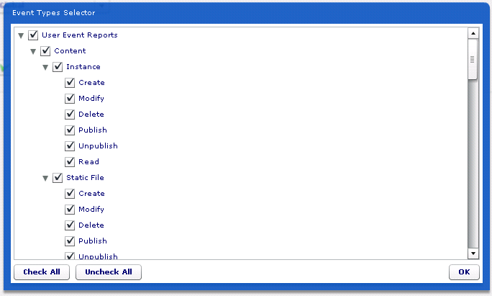

Select the time frame you wish to report on.

Click the submit button.

Make an Evolution with Two Lines
Select the event type you wish to report on.

Select "Evolution".

Select the time frame you wish to view.

Click the "Add Evolution" button.

Add filters to the evolution, so that this evolution is different from the first one. See this section about filtering.
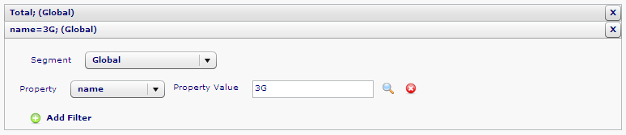

Click the submit button.

Contact Information
OpenText Corporation
275 Frank Tompa Drive
Waterloo, Ontario
Canada, N2L 0A1

Email: support@opentext.com
Knowledge Center: https://knowledge.opentext.com

For more information, visit www.opentext.com

