

Web Experience Management Audit

Installation and Configuration Guide

Version 10.5

OpenText Web Experience Management Audit
Installation and Configuration Guide
Rev.: 2015-January-07

This documentation has been created for software version 10.5.
It is also valid for subsequent software versions as long as no new document version is shipped with the product or is published at https://knowledge.opentext.com .

OpenText SA

40 Avenue Monterey , Luxembourg, Luxembourg L-2163

Tel: 35 2 264566 1

OpenText Corporation

275 Frank Tompa Drive, Waterloo, Ontario, Canada, N2L 0A1

Tel: +1-519-888-7111
Toll Free Canada/USA: 1-800-499-6544 International: +800-4996-5440
Fax: +1-519-888-0677
Email: support@opentext.com
FTP: ftp://ftp.opentext.com
For more information, visit http://www.opentext.com

Copyright © 2013 by OpenText Corporation

OpenText is a trademark or registered trademark of OpenText SA and/or OpenText ULC. The list of trademarks is not exhaustive of other trademarks, registered trademarks, product names, company names, brands and service names mentioned herein are property of OpenText SA or other respective owners.

Disclaimer

No Warranties and Limitation of Liability
Every effort has been made to ensure the accuracy of the features and techniques presented in this publication. However, OpenText Corporation and its affiliates accept no responsibility and offer no warranty whether expressed or implied, for the accuracy of this publication.

Contents

1 Introduction 6
1.1 Document Revision History 6
Topic 6
Modifications 6
Revision Number 6
1.2 Architecture Overview 7
1.3 Consulting the Release Notes and Patch Notes 8
1.4 Supported Platform Matrix 9
1.5 Prerequisites 9
1.5.1 SMTP Server and Email Account 9
1.5.2 Web Experience Audit Distribution (RTB 3.4.19) 10
1.5.3 General Configurations 11
1.5.4 System Requirements 12
2 Installation 13
2.1 Installation Process Overview 13
2.2 Create RTB Database 13
2.3 Complete the Installation Wizard 13
2.3.1 Step 1: Select Installation Type 15
2.3.2 Step 2: Select Installation Folders 16
2.3.3 Step 3: Create Directory Structure 17
2.3.4 Step 4: Database Configuration 19
2.3.5 Step 5: Web Experience Components Installer 23
2.3.6 Step 6: Configuring System Properties 25
2.3.7 Step 7: Update Roles 30
2.3.8 Step 8: Web Experience Components Installer 32
2.3.9 Step 9: Finishing the installation 34
2.4 Silent installation 35
2.5 Configure the Web Experience Management Audit Resource 40
2.6 Testing the Environment 46
2.6.1 Testing OpenText Insights 46
2.6.2 Testing the Collector Application 48
2.6.3 Testing the Audit System 48
2.7 Update Roles 51
2.8 Execute RTB Loader 52
2.9 Upgrade to Web Experience Management Audit Enhanced 54
2.10 Installation on a Web Experience Management Cluster 54
2.10.1 Installation on Secondary Nodes 54
2.10.2 Installation on Primary Node 54
3 Upgrading to Web Experience Management Audit 10.5 55
3.1 How to Upgrade 55
4 Uninstalling Web Experience Management Audit 56
4.1 Launch Uninstall Wizard 56
4.2 Final Steps 62
4.3 Uninstalling from a Web Experience Management Cluster 62
5 Appendix 1 – Troubleshooting 63
5.1 Launch Installation Wizard 63
5.2 Adding libraries and Classpath manually 63
5.2.1 Libraries installation in Web Experience Management 63
5.2.2 Classpath and Arguments 63
5.3 Installation of WF Listener 65
5.4 Deployment of AuditVCMApp 65
5.5 Configuration of Web Experience Management Console “Events” Button, “Events” Tab and “Audit” Tab in the Content Console 66
5.5.1 Add the Configuration of the Button 67
5.5.2 Add the Configuration of the Events Tab 68
5.5.3 Add the Configuration of the Audit Tab (on Content Console) 69
5.5.4 Visualization Permissions for the Buttons 70
5.6 Removing Weblogic Auditor 70
5.7 Access Denied to OpenText Insights 71
5.8 Restarting the DataCollector in Runtime Services 71
5.9 Using TAS 71
6 Appendix 2 – Properties Files 72
6.1 Collector Properties (collector.properties) 73
6.2 OpenText Insights Properties (management.properties) 77
6.3 Client Properties (rtbclient-global.properties) 83
7 Appendix 3 – Audit Task 87
7.1 About the Audit Task 87
7.2 Workflows Update 88
7.3 Parameters 88
8 Appendix 4 – Events 90
9 Contact Information 92

Introduction
This guide provides an overview of Web Experience Management Audit version 10.5 installation and configuration. OpenText recommends that you read this Installation and Configuration Guide in conjunction with the documentation included with the software package.

We also recommend that you check the OpenText Knowledge Center (https://knowledge.opentext.com/) for any patches or documentation updates that may have been posted after the initial release of Web Experience Management Audit version 10.5.

This document is the installation guide for OpenText Insights, Web Experience Management Audit and Web Experience Management Audit Enhanced modules. OpenText Insights is a real-time reporting console built on top of the flexible and extendable VILT RealTimeBiz (RTB) platform that allows your organization to register content management events connected to specific actions that your organization deems relevant and wants the ability to report on.

Document Revision History
Topic | Modifications | Revision Number
All | Initial release | 10.5

Architecture Overview
The diagram below shows the underlying RealTimeBiz (RTB) platform architecture:

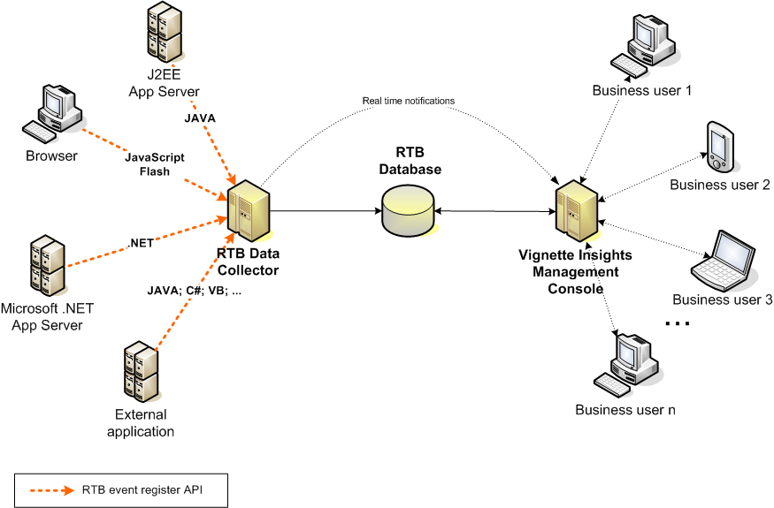

The RealTimeBiz platform has three main system components:
- RTB Database – the data repository of RTB.
- RTB Data Collector – the component that receives the events from external systems and stores them in the RTB Database in real-time.
- OpenText Insights Management Console – the web console where business users access parametric data reports. This component is only available with “WEM Audit Enhanced” license.

The Web Experience Management Audit Module complements the functionality of the RTB platform by monitoring the activity of Web Experience Management. This module is specifically designed to gather information about events such as the creation of the channels, the modification of content types, etc, and making them available within the Web Experience Management Console.

These collected events are configured to be stored in a RTB database for a configured amount of time. Once this time is elapsed, the events are automatically removed from the system. This retention schedule feature is currently available only at Web Experience Management Audit Enhanced.

Web Experience Management Audit Enhanced Module is supplied as a separated component. It provides you OpenText Insights, an advanced tool to analyze all the audit information and help you to improve your content management and delivery business processes.

Consulting the Release Notes and Patch Notes
Read the Web Experience Management Audit Release Notes and Patch Notes before you begin the procedures in this guide. The Release Notes and Patch Notes contain installation and configuration notes, and other important information not contained in this guide. See the Web Experience Management Audit Supported Platforms Matrix Web Experience Management, version 10.5 (available on http://knowledge.opentext.com) for details about supported versions of required software.

Supported Platform Matrix
OpenText supports platforms only when used in combination as described in the Web Experience Management Audit Supported Platforms Matrix, version 10.5. Running Web Experience Management Audit in a configuration not listed in the document is not supported and may result in unpredictable performance.

Prerequisites
Each section below describes a prerequisite to install RealTimeBiz and Web Experience Management Audit Module.

SMTP Server and Email Account
If you want to receive Web Experience Management Audit (RTB) reports or logs via email, you must have an SMTP Server and it must be accessible from the machine where OpenText Insights Management Console will be installed. This option is only available if you have a license for Web Experience Management Audit Enhanced.

Make sure you have your SMTP server available and that you have administrative permissions and the email account to be used by RTB.

Web Experience Audit Distribution (RTB 3.4.19)
You must have a distribution of RealTimeBiz Web Experience Management Audit 10.5. It contains the files and directories shown below.

File / Directory | Description
antDir/ | Installer scripts
bin/ | Realtimebiz binaries
config/ | Configuration files
doc/ | Documentation
installLib/ | Installer libraries
install.bat | Windows installer wizard
install.sh | Linux/Unix installer wizard
uninstall.sh | Windows uninstaller wizard
uninstall.sh | Linux/Unix uninstaller wizard

General Configurations
Before proceeding with the Web Experience Management Audit Module installation, the following information should be gathered:

Prerequisite | X
LDAP URL (host + port)
LDAP user and Password with read privileges (complete DN)
LDAP user attribute (i.e. cn, uid)
LDAP user search base (root DN for users)
LDAP group search base (root DN for groups)
LDAP group object class
LDAP user object class
LDAP member attribute
Complete DN of groups and/or users with Audit privileges (access to OpenText Insights)
Host Name or IP where RTB Collector will be installed
Retention Period desired for events and large attributes (1 year, 5 years, etc)
Database user and password for RTB tables
Database user and password for Web Experience Management system tables
Database URL (host + port + instance)
List of LDAP Groups that are going to be tracked with RTB
The host and port of Web Experience Management Connection Server
User/groups/roles that will have the capability to see the event history at Web Experience Management Console
Max. number of pages to be exported to excel or CSV (each page has 10 events)
Workflows that should be audited and the activities inside those workflows
SMTP Host and port
RTB account mail and password to this account

System Requirements
The following outlines the minimum requirements to install Web Experience Management Audit.

Requirement
Web Experience Management Stage Disk Space: | 100 MB
Memory: | See web Experience Management Memory Requirements
Database Space: | 4 K per collected event
Database Connection Pool: | 2 connections per concurrent user of the OpenText Insights Console, plus a minimum of 5 connections for the RTB Collector.

Installation
This contains administrator tasks for installing and configuring RealTimeBiz 3.4.19 platform, Web Experience Management Audit and OpenText Insights

Installation Process Overview
Web Experience Management Audit installation process has the following major installation steps:
- Create RTB Database
- Complete the Installation Wizard
- Configure Generic Resources
- Test Environment
- Update Roles
- Execute RTB Loader
- Upgrade to Web Experience Management Audit Enhanced (optional)
Each one of these steps is described in the following sections.

Important: Please ensure you've read previous chapters (prerequisites) before proceeding.

Create RTB Database
You must create a database user in your database system (ex: AUDIT, RTB…) prior to begin Audit installation. Follow the recommended steps for doing that task specific to your database vendor’s documentation. The newly created user should have the same privileges/permissions of the Web Experience Management System user (ex: vgncms, vgnsys,..). Permissions like:
  - Create databases, stored procedures, indexes
  - Stored procedures execution
  - Table insert, read write, etc…
Tables and other content will be created when executing the installer, remember to note the database IP, port, instance name, user and password.

It is recommended to provide a table space or storage area that can grow as event data is collected because it is difficult to make an upfront estimation of the required database size. The database occupation is proportionally to the number of events being recorded, you may start with a size of 5GB-10GB but be prepared to grow beyond that number, especially in production environments.

The database block size should be 8K at least to improve the performance. This is the default value in MS SQL Server, and you can check/set it in Oracle using the db_block_size parameter.

Complete the Installation Wizard
Before launching the RTB installer, be sure that you are using Java 1.6. Ensure that JAVA_HOME/bin is at system path. You can use <WEMinstallDir>/Content/10_5/java dir as your Java installation.

Also, it is necessary to have up and running the following processes:
- VgnVCMServer (and additional cluster nodes)
- VgnAdminServer
- Config Agents
Expand the Web Experience Management Audit distribution file in a directory of your choice (i.e. c:\tmp\WEMAudit) and execute install.bat (or install.sh) file from that directory.

For Unix:
chmod u+x install.sh
./install.sh

For Windows:
install.bat

The default language used for installation is defined by the language configured for your server. If you want to switch the language used by the installer, for example to the Spanish language, you can follow these steps:
- Edit the install.bat with a text editor.
- Add this parameter at the end of the install.bat or install.sh file: -l es (only es and en are supported at this version).

If you prefer, you have a silent installation mode that is explained in the Silent Installation point.

Step 1: Select Installation Type
In this first step you must choose the type of installation that you want to perform. If you have just one cluster node, choose option 1.

If you have a clustered installation, you must run the installer first in every secondary node using installer option 2, and then on the primary node with option 1. More information about installing in an OpenText Content Cluster can be found in Installing Audit in a Web Experience Management Cluster.

==========================================
Welcome to the Web Experience Management Audit install wizard
Please ensure that you have read the prerequisites chapter in the documentation before going any further.

The following processes must be running before proceeding:
-VgnVCMServer (all cluster nodes), VgnAdminServer and Config Agents.
==========================================

Please, select the Installation Type that you will be using. Notice that the installer should be launched at every machine running a Web Experience Management cluster node. For installation with just one cluster node use option 1.

(Select one option [insert option number])
1)Install on Web Experience Management cluster primary node.
2)Install on Web Experience Management cluster secondary node.

Step 2: Select Installation Folders
When starting the desired installation, you have the option to select the folders in which you will install the RTB platform and Web Experience Management Audit product.

The parent folder, of the one that you want to create, must exist. And you cannot use non-alphanumerical or accentuated characters in neither Windows nor UNIX / Linux systems.

Please select a destination directory.
(this directory will store Web Experience Management Audit binaries and configuration)
>Default value [c:\audit]
>Value: c:\OpenText\Content\Audit

Please select the Web Experience Management directory.
(this directory should contain the Content subfolder)
>Default value [c:\OpenText]
>Value: c:\OpenText

Step 3: Create Directory Structure
------------------------------------------
Installing Directory structure
------------------------------------------
In the next step the following components will be installed/configured:
-Data Collector properties file.
-Open Text Insights application files.
-RTB loader properties file.
-Open Text Insights properties file.
-Web Experience Management Audit Applications files.
-Data Collector application files.
-Audit libraries files.
-Client files.
-Uninstaller binaries.
-Folder structure.
-Client properties file.
-RTB Loader.

Do you want to continue with this step? (yes - continue, no - skip).
(only skip this step if you are doing a manual step by step setup over a previous installation, otherwise the installation will fail)

>Default value [yes]
>Value:
[yes]

Installing ....
Creating folder structure ...
-->Folder structure created.
Copying Open Text Insights web application ...
-->Open Text Insights web application copied.
Copying collector application ...
-->Collector application copied.
Copying WEM applications ...
-->WEM Applications copied.
Copying Open Text Insights properties...
-->Open Text Insights properties copied.
Copying collector properties ...
-->Collector properties copied.
Copying client properties ...
-->Client properties copied.
Copying libraries ...
-->Libraries copied.
Install/uninstall libraries ..
-->Libraries installed/uninstalled.
Done.

Step 4: Database Configuration
To execute this step, you need the connection details of two database users:
- The database user for Web Experience Management Audit (RTB)
- The system database user already in use for Web Experience Management

You also need to have in mind the lifetime that your events will have, and the LDAP groups that you will want to monitor.

------------------------------------------
System Database Installation
------------------------------------------
In the next step the following components will be installed/configured:
-Auditor capability.
-Groups and company info.
-Open Text Web & Social indicators.
-RTB System Database.
-WEM Indicators.

Do you want to continue with this step? (yes - continue, no - skip).
(only skip this step if you are doing a manual step by step setup over a previous installation, otherwise the installation will fail)
>Default value [yes]
>Value:
[yes]

Web Experience Management Audit database information
------------------------------------------
(At this point a database user must be created before proceeding)
Database software
(Select one option [insert option number])
1)Oracle
2)MSSQL
2

Database Host
>Default value [localhost]
>Value:
[localhost]

Database Port
>Default value [1433]
>Value:
[1433]

Database Instance Name
>Default value [VIGN]
>Value: VCMAUDIT

Database User
>Default value [vcmaudit]
>Value: audit

Database User Password

Do you want to continue? (yes - continue / no - go back)
>Default value [yes]
>Value:
[yes]

Company information
------------------------------------------
Please enter the company name in which Web Experience Management Audit is being installed

>Default value [OpenText]
>Value: OpenText

Do you want to continue? (yes - continue / no - go back)
>Default value [yes]
>Value:
[yes]

Events lifetime.
------------------------------------------
Events lifetime into the database. (in days)
(This is the retention period for events. After that period events will be removed)
>Default value [1095]
>Value: 365

Large objects lifetime.
(This is the retention period for large attributes inside events. After that period large attributes will be removed)
>Default value [365]
>Value: 30

Do you want to continue? (yes - continue / no - go back)
>Default value [yes]
>Value:
[yes]

Each user can belong to one or more groups when starting a session. A session is a sequence of individual events performed by a user. To segment by group, you should introduce the list of LDAP groups for which you are interested to obtain reports.
Please type the list of groups that you are interested to report on [separated by commas. For example: Administrators, DepartmentA, Contributors].
>Value: Administrators, Auditores

Do you want to continue? (yes - continue / no - go back)
>Default value [yes]
>Value:
[yes]

Web Experience Management database system information
------------------------------------------
Please provide the parameters needed for connecting to Web Experience Management system database user.
Database software
(Select one option [insert option number])
1)Oracle
2)MSSQL
2

Database Host
>Default value [localhost]
>Value:
[localhost]

Database Port
>Default value [1433]
>Value:
[1433]

Database Instance Name
>Default value [VIGN]
>Value: VCMMGMT

Database User
>Default value [vcmsys]
>Value: vcmmgmt

Database User Password

Do you want to continue? (yes - continue / no - go back)
>Default value [yes]
>Value:
[yes]

Installing ....
Creating RTB system tables...
-->RTB system tables created.
Creating Web Experience Management Audit data ...
-->Web Experience Management Audit data created.
Adding groups ...
-->Groups added.
Adding indicators ...
-->Indicators added.
Adding WEM indicators ...
-->WEM Indicators added.
Installing Auditor capability ...
-->Auditor capability installed.
done.

Step 5: Web Experience Components Installer
------------------------------------------
Installing Web Experience Management configuration
------------------------------------------
In the next step the following components will be installed/configured:

-Audit libraries.
-Workflow listeners.
-Web Experience Management Automatic Task.
-Audit generic resource.
-History Button.
-Web Experience Management Audit property sheet.

Do you want to continue with this step? (yes - continue, no - skip).
(only skip this step if you are doing a manual step by step setup over a previous installation, otherwise the installation will fail)

>Default value [yes]
>Value:
[yes]

Please type Web Experience Management (VgnVCMServer) connection info.
------------------------------------------
Web Experience Management Server Host
>Default value [localhost]
>Value: rtbtests

Web Experience Management Port

>Default value [27110]
>Value:
[27110]

Admin User
>Default value [vgnadmin]
>Value:
[vgnadmin]

Admin User Password

Do you want to continue? (yes - continue / no - go back)
>Default value [yes]
>Value:
[yes]

Creating generic resource ...
-->Generic resource created.
Installing workflow listeners ...
-->Workflow listeners installed.
Installing Console buttons ...
Console buttons installed.
Committing changes ...
Doing deploy (configp) ...

##The next step requires configp execution.

*** WARNING: Before proceed, check that Runtime Services configuration is not
locked in any browser ***

Please press the "Enter" key

This action may take several minutes, please wait
->Deploy (configp) finished.
Creating Audit program task definition ...
-->Audit program task definition created.
Creating audit property sheet ...
-->Audit property sheet created.
done.

Step 6: Configuring System Properties
------------------------------------------
Gathering system information (Properties file)
------------------------------------------
In the next step the following components will be installed/configured:
-RTB Data Collector properties.
-RTB Client properties.
-Open Text Insights properties.

Do you want to continue with this step? (yes - continue, no - skip).
(only skip this step if you are doing a manual step by step setup over a previou
s installation, otherwise the installation will fail)
>Default value [yes]
>Value:
[yes]

Define where you want to create the data collector log file
>Default value [c:\OpenText\Content\Audit\logs\rtbcollector.log]
>Value:
[c:\OpenText\Content\Audit\logs\rtbcollector.log]

Define the size for the data collector log file [KBs]
>Default value [100]
>Value: 1000

Define the port where the tool will be listening
>Default value [26000]
>Value:
[26000]

Please type the mail account information:
(this account will be used by the platform to send reports to business users and
log files to technical support)
------------------------------------------
SMTP Host
>Default value [localhost]
>Value:
[localhost]

SMTP port
>Default value [25]
>Value:
[25]

Email Account
>Default value [vcmaudit@yourcompany.com]
>Value:
[vcmaudit@yourcompany.com]

Email Account Password

Enter a comma-separated list of email addresses. The product can send log files
to these addresses:
>Default value [rtb.support@vilt-group.com]
>Value:
[rtb.support@vilt-group.com]

The installer will fetch the LDAP properties from Web Experience Management, and suggest them to you as your default options. If you don’t want to use the same LDAP configuration you use in Web Experience Management, you must insert them all manually.

The format of the LDAP properties depend directly on the LDAP server you’re using. The table below contains the typical properties for some well-known LDAP servers: OpenLDAP, ActiveDirectory and Sun One.

Properties | OpenLDAP | ActiveDirectory | Sun LDAP
adminName | cn=admin,dc=vilt,dc=es | CN=Administrator,OU=Users,DC=localhost,DC=vilt,DC=dev | cn=Manager,dc=opentext,dc=com
adminPassword | XXX | XXX | XXX
groupObjectClass | groupOfNames | Group | groupofuniquenames
groupSearchBase | ou=groups,dc=vilt,dc=es | OU=VCM Groups,OU=Groups,DC=localhost,DC=vilt,DC=dev | ou=Groups,dc=opentext,dc=com
groupSearchMember | member | member | uniqueMember
Ldapurl | ldap://localhost:389 | ldap://localhost:3268 | ldap://ldapdes01:389
searchBase | ou=people,dc=vilt,dc=es | OU=Users,DC=localhost,DC=vilt,DC=dev | ou=People,dc=opentext,dc=com
userObjectClass | person | User | person
userResolver | cn | sAMAccountName | Uid

Please type the LDAP properties:
------------------------------------------
LDAP server URL:
>Default value [ldap://lv111:27110]
>Value:
[ldap://lv111:27110]

LDAP administrator username:
>Default value [uid=vgnadmin,ou=people,ou=VgnLDAPRealm,dc=vgndomain]
>Value: [uid=vgnadmin,ou=people,ou=VgnLDAPRealm,dc=vgndomain]

LDAP administrator password:

Distinguished name where to begin the user search:
>Default value [ou=people,ou=VgnLDAPRealm,dc=vgndomain]
>Value: [ou=people,ou=VgnLDAPRealm,dc=vgndomain]

Name of the property that defines a user in LDAP:
(this property depends directly on the LDAP server that you're using. PLEASE READ THE INSTALLATION GUIDE FOR DETAILED INFORMATION ON THE CORRECT PROPERTY NAME FOR THE MOST COMMON LDAP SERVERS)
>Default value [uid]
>Value: [uid]

User Object Class:
(this property depends directly on the LDAP server that you're using. PLEASE READ THE INSTALLATION GUIDE FOR DETAILED INFORMATION ON THE CORRECT PROPERTY NAME FOR THE MOST COMMON LDAP SERVERS)
>Default value [inetOrgPerson]
>Value: [inetOrgPerson]

Distinguished name where to begin the group search:
>Default value [ou=groups,ou=VgnLDAPRealm,dc=vgndomain]
>Value: [ou=groups,ou=VgnLDAPRealm,dc=vgndomain]

Group Object Class:
(this property depends directly on the LDAP server that you're using. PLEASE READ THE INSTALLATION GUIDE FOR DETAILED INFORMATION ON THE CORRECT PROPERTY NAME FOR THE MOST COMMON LDAP SERVERS)
>Default value [groupOfUniqueNames]
>Value: [groupOfUniqueNames]

Name of the property that defines a group in LDAP:
(this property depends directly on the LDAP server that you're using. PLEASE READ THE INSTALLATION GUIDE FOR DETAILED INFORMATION ON THE CORRECT PROPERTY NAME FOR THE MOST COMMON LDAP SERVERS)
>Default value [cn]
>Value: [cn]

Name of the attribute that defines the membership relation:
(this property depends directly on the LDAP server that you're using. PLEASE READ THE INSTALLATION GUIDE FOR DETAILED INFORMATION ON THE CORRECT PROPERTY NAME FOR THE MOST COMMON LDAP SERVERS)
>Default value [uniqueMember]
>Value: [uniqueMember]

Do you want to perform a test to check if the LDAP configuration is correct?
>Default value [yes]
>Value: [yes]

To start the test, it is necessary to enter an existing user in the LDAP server
>Default value [vgnadmin]
>Value: [vgnadmin]

Enter the password

The connection has been made successfully

Do you want to continue? (yes - continue / no - go back)
>Default value [yes]
>Value:
[yes]

Step 7: Update Roles
The next step provides the ability for you to configure the user’s privileges of OpenText Insights management console. These privileges are defined using roles. A role grants to a user the right to access a resource or to perform certain action.

By default there are 2 different roles in RTB:
- Administrators: Grants access to the Admin tab at OpenText Insights Management Console and all the administration features within.
- Web Experience Management Auditors: Grants access to the Audit tab at OpenText Insights Management Console, in which are displayed all the reports of the application. They also have the capability xml_viewer, allowing them to see the XML with the details of the events in the history button of Web Experience Management console.

Please type users and groups (separated by semicolons) for each role below:
------------------------------------------
Role Admin: Users who will have total control on Open Text Insights console
>Default value [cn=Administrators,ou=groups,ou=VgnLDAPRealm,dc=vgndomain]
>Value:
[cn=Administrators,ou=groups,ou=VgnLDAPRealm,dc=vgndomain]

Role Audit: Users who will have access to the Audit tab on Open Text Insights console
>Default value [cn=Administrators,ou=groups,ou=VgnLDAPRealm,dc=vgndomain]
>Value:
[cn=Administrators,ou=groups,ou=VgnLDAPRealm,dc=vgndomain]

Do you want to continue? (yes - continue / no - go back)
>Default value [yes]
>Value:
[yes]

Define where you want to create the Open Text Insights console log file
>Default value [c:\OpenText\Content\Audit\logs\rtbmanagement.log]
>Value:
[c:\OpenText\Content\Audit\logs\rtbmanagement.log]

Define the size for the Open Text Insights console log file [KBs]
>Default value [100]
>Value: 1000

Define the port where the tool will be listening
>Default value [26099]
>Value:
[26099]

Please, type the folder where the properties cache file will be stored?
>Default value [c:\OpenText\Content\Audit\cache]
>Value:
[c:\OpenText\Content\Audit\cache]

Define where you want to create the RTB client log file
>Default value [c:\OpenText\Content\Audit\logs\rtbclient.log]
>Value:
[c:\OpenText\Content\Audit\logs\rtbclient.log]

Installing ....
done.

Step 8: Web Experience Components Installer
------------------------------------------
Installing Web applications configuration
------------------------------------------
In the next step the following components will be installed/configured:
-Web Experience Management Audit application.
-Web Experience Management Audit Data Collector application.
-Start Parameters.
-Pools and Datasources.
-Open Text Insights application.

Do you want to continue with this step? (yes - continue, no - skip).
(only skip this step if you are doing a manual step by step setup over a previou
s installation, otherwise the installation will fail)
>Default value [yes]
>Value:
[yes]

Please provide information for the connection to runtime services (VgnAdminServe
r)
------------------------------------------
Admin Server Host
>Default value [localhost]
>Value:
[localhost]

Admin Port
>Default value [27001]
>Value:
[27001]

Admin User
>Default value [vgnadmin]
>Value:
[vgnadmin]

Admin User Password

Do you want to continue? (yes - continue / no - go back)
>Default value [yes]
>Value:
[yes]

Installing ....
Installing connection pool ...
-->Connection pool installed.
Setting start parameters ...
-->Start parameters configured.

##To continue the process it is necessary to restart:
VgnVCMServer (all nodes in the cluster)
Please restart the server(s) manually and do not close this wizard.
Did the server(s) complete the reboot?
>Default value [no]
>Value: yes

Installing Web Experience Management Audit application ...
-----------------------------------------------
-----------------------------------------------
-->Web Experience Management Audit application installed.

Installing Web Experience Management Audit Data Collector App ...
-----------------------------------------------
-----------------------------------------------
--> Web Experience Management Audit Data Collector App installed.

Installing Open Text Insights ...
-----------------------------------------------
-----------------------------------------------
-->Open Text Insights installed.
done.

Note: In some cases, you can find an error while installing the connection pool. If you find that error, you need to retry this part of the installation and pay attention in the next connection pool installation message.

If the next message is something like “the connection pool is already installed”, enter to the Web Experience Management Runtime Services console and review in “Services > JDBC > Data Sources”. If there is one data source named auditPool and it is targeted in the cluster, the installation has been done successfully. But if the data source exists and it is not targeted, you should select the auditPool and target it onto all servers in the cluster.

Step 9: Finishing the installation
The install process has finished successfully!
==========================================

In order to start registering events, it is necessary to restart Web Experience
Management Server (all nodes in the cluster).

==========================================

------------------------------------------
After restart is complete, please check your installation. You should perform the following tests:
Web Experience Management Audit application: http://localhost:27110/AuditVCMWeb/diagnosis/index.jsp
Open Text Insights application: http://localhost:27110/Insights/dianosis
Web Experience Management Audit Data Collector: http://localhost:27110/collector/diagnosis
------------------------------------------

------------------------------------------
The Web Experience Management Audit Loader application was installed in:
c:\OpenText\Content\Audit\rtbLoader

It's recommended to run Web Experience Management Audit Loader before starting t
o register system events. Please consult the documentation to learn more.
------------------------------------------

Please press the "Enter" key

Silent installation
This version includes a silent installation mode to make a faster installation. To enable this mode you need to rename “<INSTALL_DIR>\installation.properties” file to “<INSTALL_DIR>\silent.properties”. The file contains the following properties:

###########################################################
## ##
## VCM Audit silent installation properties ##
## ##
## This is the main properties file for the VCM Audit silent installation ##
## ##
## You need to populate the properties to perform a silent installation ##
## of this Audit tool. ##
## ##
###########################################################

#Installation type (please don't change this property)
installer.type=principal_node

###########################################################
## Common properties ##
###########################################################

#Path where the VCM is installed
common.vcmPath=c:\\OpenText

#Path where the Audit tools will be installed
common.installPath=c:\\OpenText\\Audit

#Company to associate the application to be audited
common.company=VILT

#common.internalHosts=

# Number of days that you want to store the events in the database
common.eventLifeTime=365

# Number of days that you want to store the content instance XML associated to the events
common.xmlLifeTime=30

# Mail to send reports in case of problems
common.mailSendTo=rtb@vilt-group.com

# Host where the collector application is going to be installed
common.collectorHost=localhost

# Port where the collector will be listening for events (not the webapp server port)
common.collectorKRouterPort=26000

# Port where the management will be listening for events (not the webapp server port and different to the collectorKRouterPort)
common.managementKRouterPort=26099

# Mail account to send mail from the tool
common.managementAccounts=rtb.support@vilt-group.com

# Folder where the properties will be cached
common.propertiesCacheFile=c:\\OpenText\\AuditSilent\\cache

###########################################################
## Logging properties ##
###########################################################

# Log file to store traces of events generation
logging.rtbClientLogFile=c:\\OpenText\\Audit\\logs\\rtbclient.log

# Log file to store traces of the tool that retrieves and store events generated by the tool
logging.collectorLogFile=c:\\OpenText\\Audit\\logs\\rtbcollector.log

# Size of the collector log file before rotation (without the KB suffix)
logging.collectorLogFileSize=1000

# Log file to store traces of the tool that generates reports from events generated by the tool
logging.managementLogFile=c:\\OpenText\\Audit\\logs\\rtbmanagement.log

# Size of the management log file before rotation (without the KB suffix)
logging.managementLogFileSize=1000

###########################################################
## Audit events database properties (where events will be stored) ##
###########################################################

# Audit events database software (MSSQL or Oracle)
database.rtbSoftware=MSSQL

# Audit events database host
database.rtbHost=localhost

# Audit events database port
database.rtbPort=1433

# Audit events database name
database.rtbDBName=RTB

# Audit events database user
database.rtbUser=rtb

# Audit events database password
database.rtbPassword=rtb

# Open Text user groups
database.groups=Administrators

####################################################################
## VCM database properties (if you have split the database use the System one) ##
####################################################################

# VCM system database software (MSSQL or Oracle)
database.vcmSoftware=MSSQL

# VCM system database host
database.vcmHost=localhost

# VCM system database port
database.vcmPort=1433

# VCM system database name
database.vcmDBName=VCMMGMT

# VCM system database user
database.vcmUser=vcmmgmt

# VCM system database password
database.vcmPassword=vcmmgmt

#############################################################
## Role mapping properties (enabling users and/or groups for Insights) ##
#############################################################

# Enabling the Admin tab for these users and/or groups
rolemapping.admin=cn=Administrators,ou=groups,ou=VgnLDAPRealm,dc=vgndomain

# Enabling the Audit tab for these users and/or groups
rolemapping.audit=cn=Administrators,ou=groups,ou=VgnLDAPRealm,dc=vgndomain

# Enabling the Web tab for these users and/or groups
rolemapping.web=cn=Administrators,ou=groups,ou=VgnLDAPRealm,dc=vgndomain

###########################################################
## VCM connection properties ##
###########################################################

# VCM host
vcm.host=localhost

# VCM port
vcm.port=27110

# VCM user
vcm.user=vgnadmin

# VCM password
vcm.password=vignette

# VCM node name
vcm.nodeName=VgnVCMServer

###########################################################
## Runtime Services connection properties ##
###########################################################

# Runtime Services host
rtsvcs.host=localhost

# Runtime Services port
rtsvcs.port=27001

# Runtime Services user
rtsvcs.user=vgnadmin

# Runtime Services password
rtsvcs.password=vignette

###########################################################
## LDAP authentication properties ##
###########################################################

# LDAP URL
ldap.url=ldap://localhost:27110

# LDAP admin full name
ldap.adminFullName=uid=vgnadmin,ou=people,ou=VgnLDAPRealm,dc=vgndomain

# LDAP admin name
ldap.adminName=vgnadmin

# LDAP admin password
ldap.adminPassword=vignette

# LDAP user search base
ldap.userSearchBase=ou=people,ou=VgnLDAPRealm,dc=vgndomain

# LDAP user resolver
ldap.userResolver=uid

# LDAP user object class
ldap.userObjectClass=inetOrgPerson

# LDAP group search base
ldap.groupSearchBase=ou=groups,ou=VgnLDAPRealm,dc=vgndomain

# LDAP group resolver
ldap.groupResolver=cn

# LDAP group object class
ldap.groupObjectClass=groupOfUniqueNames

# LDAP group search member
ldap.groupSearchMember=uniqueMember

###########################################################
## SMTP configuration properties (for reports sending) ##
###########################################################

# SMTP host
smtp.host=localhost

# SMTP port
smtp.port=25

# SMTP user
smtp.user=test@vilt-group.com

# SMTP password
smtp.password=test
You should replace the properties values for those from your environment and run the installation scripts.
For Unix:
chmod u+x install.sh
./install.sh

For Windows:
install.bat

This is a silent installation so the installer will show the process information in the “<INSTALL_DIR>\install.log” file. If you have any error during the installation process, you will be able to see it there.

The first step will be the properties validation, so if you have any error, it will appear in the log file. The common problem that you could find in this step is a mistake on any connection property (database, LDAP, WEM, Runtime Services).

Note: Please make sure that the Runtime Services configuration is not locked, because some steps will need to apply some changes to the configuration using the Runtime Services.

Configure the Web Experience Management Audit Resource
The installation process creates several Generic Resources in the Configuration Console under the following paths:
Content
->Delivery Services
-><for every stage, including management>
->Resources
->ResourceType-Generic
->Resource-RTBAudit
->GenericResource

The following tables summarize the properties included in this resource.

This first table contains the properties that are valid in the management stage and in delivery stages. If you have multiple delivery stages, don’t forget you have to configure the properties in each one of them.

Properties | Description | Default Value
audit.config.refresh | Web Experience Management Audit properties refresh time in minutes. Avoids restart after configuration changes. The user should wait this interval (at maximum) to see the changes take effect. | 5 minutes
eventsDisabled | Events that will not be audited, comma separated. You can specify the names of single events (like ContentSiteDelete) or you can specify a whole branch of events (like ContentSite).  Using ‘ALL’ keyword would disable the auditing of all events for that stage. In order to disable all Auditing, you must configure this parameter as ‘ALL’ in all stages.  In Appendix 5 you can find a table containing all the possible events that can be filtered with this property. | Commented. Uncomment it and insert the event branches that you don’t want to register.
usersIgnored | Users whose events are not going to be audited, comma separated. Using ‘ALL’ keyword would disable the auditing of all events. | Commented. Uncomment it and insert the users whose events you don’t want to register.
contentType.denied | List of content types that are not going to be audited. By default, Web Experience Management Audit registers events for all content types. This property is useful to define a ‘black list’ of content types which we don’t want to register events. Using ‘ALL’ keyword would disable the auditing of all content types. Use Content Type xml name. | Commented. Uncomment it and insert the content types to be blacklisted.
contentType.allowed | List of content types that are going to be audited (Only if contentType.denied is not set). This property is useful if in a Web Experience Management installation where we are only interested in registering events from few content types. Using ‘ALL’ keyword would enable the auditing of all content types. Use Content Type xml name. | Commented. Uncomment it and insert the content types to be audited.

This table shows the properties that are only valid for the management stage.

Properties | Description | Default Value
workflows.denied | Comma separated list of workflows that are not going to be audited. Using ‘ALL’ keyword would disable the auditing of all workflow events | ALL
workflows.allowed | Comma separated list of workflows that are going to be audited | Commented. Uncomment it and insert the workflows to be audited.
task.<name_of_workflow> | Used to specify list of tasks to be audited for a concrete workflow. For example, if you are auditing a workflow named ‘MyPublishing’, but are only interested in the steps ‘Begin’ and ‘End’, you should add this parameter:  task.MyPublishing=Begin,End | Commented. Uncomment it and insert the tasks to be audited.
job.var | Name of the default publishing workflow. Please, don’t’ change its value unless you explicitly have modified the default publishing workflows of Web Experience Management | jobId
job.task | Name of the task invoked when starting the publishing workflow. As before, don’t change this property unless you explicitly have modified the default publishing workflows of Web Experience Management | BeginDeployment
contentType.xml.denied | Web Experience Management Audit can register, for content instances, not only generic information (user, date, etc.) but also the full XML data associated to every content instance.  This parameter defines the Content types for which XML data should not be registered. By default, Web Experience Management Audit only registers generic information about the content instances (name, channel, etc), but not about the full information stored in the instance. Setting this property to a value is useful to register information of all the content instances but the ones listed in this property. Using ‘ALL’ keyword would disable the auditing of all XML associated with content types. Use Content Type xml name. | Commented. Uncomment it and insert the content types whose xml should not be registered.
contentType.xml.allowed | Content types that allow XML to be registered (only if denied list does not exist). If set, this property has the names of the content types that we need Web Experience Management Audit to register its complete information. Using ‘ALL’ keyword would enable the auditing of all XML associated with content types. Use Content Type xml name. | Commented. Uncomment it and insert the content types whose xml should be registered.
contentinstance.details.preview | If true, the XML of ContentInstances that have an associated XSLT template for preview at Web Experience Management Console will be transformed when viewing the details of the event at Web Experience Management Audit History Button. If the Content Type do not have a preview template the XML will be displayed. If this property has the value false, the XML will be displayed despite the existence of preview template for that Content Type. | true

These are the properties created by default under this resource:
#Properties refresh time in minutes
audit.config.refresh = 5

#Ignored user list
#usersIgnored = robot1,robot2

#Ignored events list
#eventsDisabled = ContentChannel

#Worflows denied to register
#workflows.denied=[ALL|wf1,wf2,wf3]
workflows.denied=ALL

#Worflows to audit
#workflows.allowed=[ALL|wf1,wf2,wf3]
#workflows.allowed=ALL

#WorkFlow task to audit
#task.wf1=task1,task2

#Task who contains jobId, default BeginDeployment
#job.task=BeginDeployment

#Content types denied to register
#contentType.denied=[ALL|ct1,ct2,..]

#Content types allowed to register (only if denied list not exists)
#contentType.allowed=[ALL|ct1,ct2,..]

#Content types xml data denied to register
#contentType.xml.denied=[ALL|ct1,ct2,..]
contentType.xml.denied=ALL

#Content types xml data allowed to register (only if denied list not exists)
#contentType.xml.allowed=[ALL|ct1,ct2,..]

contentInstance.details.preview = true

This picture shows the location in the configuration console of this resource. Please, note that there is a resource for every stage:
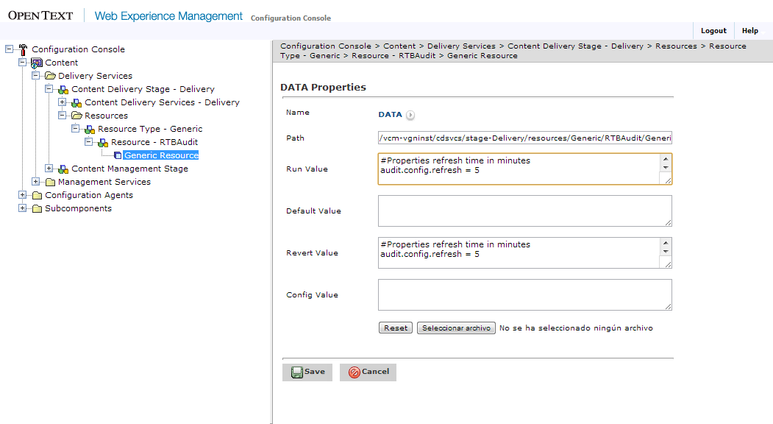

When you change the DATA of the Generic Resource, you only have to restart the correspondent Deployment Agent if you want to see the changes immediately, otherwise it will be updated continuously according to the audit.config.refresh property.

Testing the Environment
Web Experience Management Audit includes several built-in tests that can be useful to verify that the installation process has been done without errors. Don’t forget to restart VgnVCMServer (and secondary servers at cluster) after the installation is finished, before you perform the tests, or its results won’t be accurate.

Testing OpenText Insights
Important: This step only applies if you have purchased Web Experience Management Audit Enhanced and have previously installed it. To install Web Experience Management Audit Enhanced, please see the ‘Web Experience Management Audit Enhanced Installation’ section later in this document.

- Open OpenText Insights diagnosis page (http://<VCM-host>:<port>/Insights/diagnosis) to ensure the management console installation was successful.
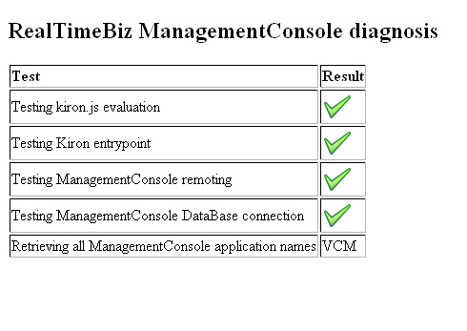

- If this test has been successful you can open the OpenText Insights management console page (http://host:port/Insights). You should be able to login and see the Web Experience Management Audit Enhanced modules tabs (on the top right corner) according to your user roles:

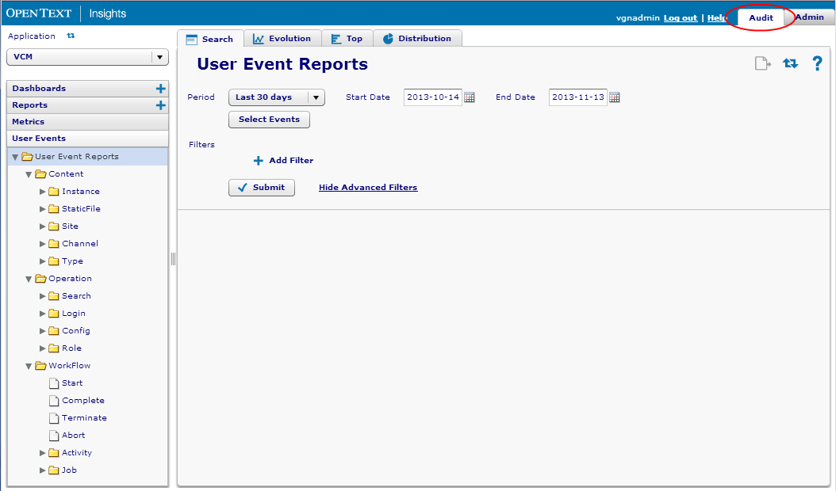

If you are unable to login, check the section Access Denied to OpenText Insights in Appendix 1 – Troubleshooting.

Testing the Collector Application
- Open Data Collector diagnosis page (http://<VCM-host>:<port>/collector/diagnosis) to ensure the data collector installation was successful.

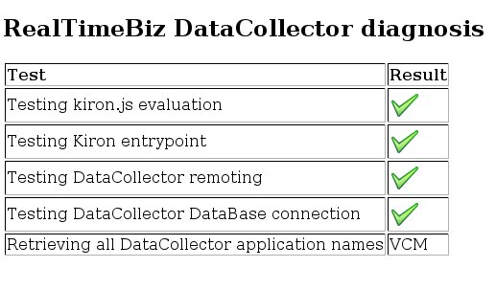

Testing the Audit System
The Audit Test tool is available at this URL: http://<VCM-host:port>/AuditVCMWeb/diagnosis .
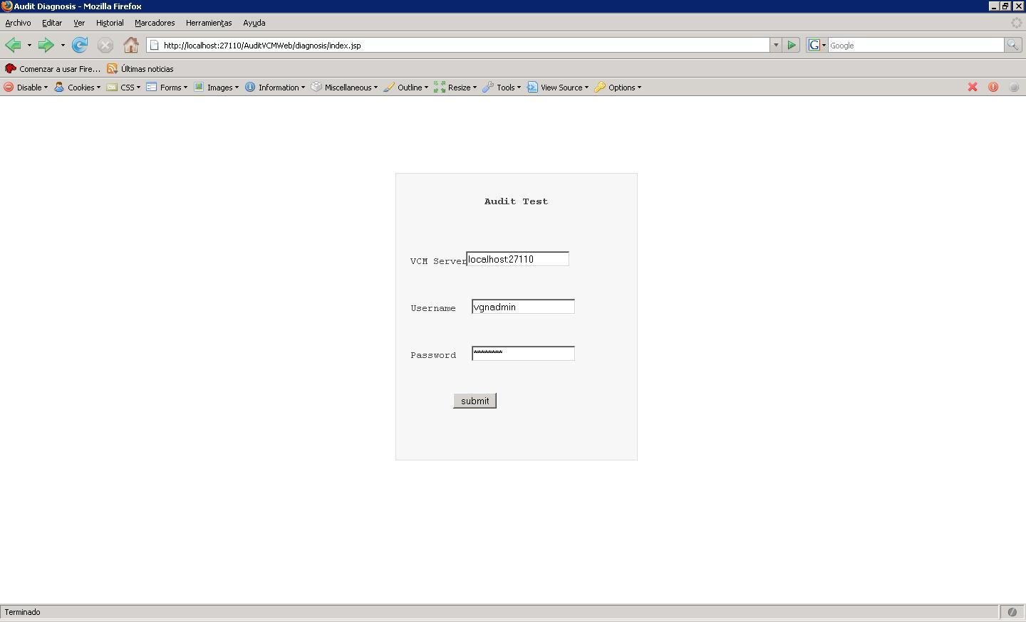
- Enter the hostname that is used in Web Experience Management, and a user and a password valid for VgnVCMServer. After entering your login information click the ‘Submit’ button to execute the test. When the test completes, the test results will be displayed.

Note: This test will fail if the hostname is not correct, as it must reflect the complete hostname where Web Experience Management Server is listening. If you are having difficulties with this, you can perform the command netstat -a and check at which host:port Web Experience Management is attached and use it for the diagnosis.
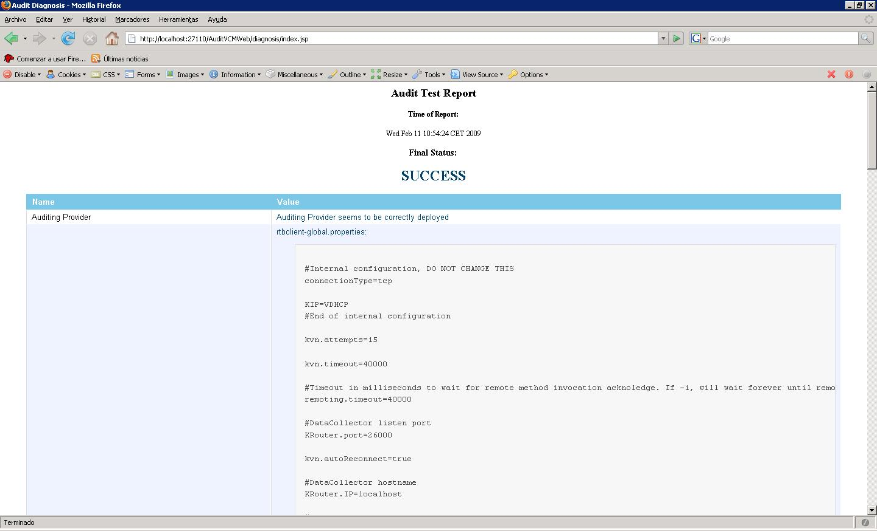

- If there are misconfigurations, the test won't succeed and a failure message will be displayed listing all the possible errors. If a success message is displayed, Web Experience Management Audit is correctly configured.

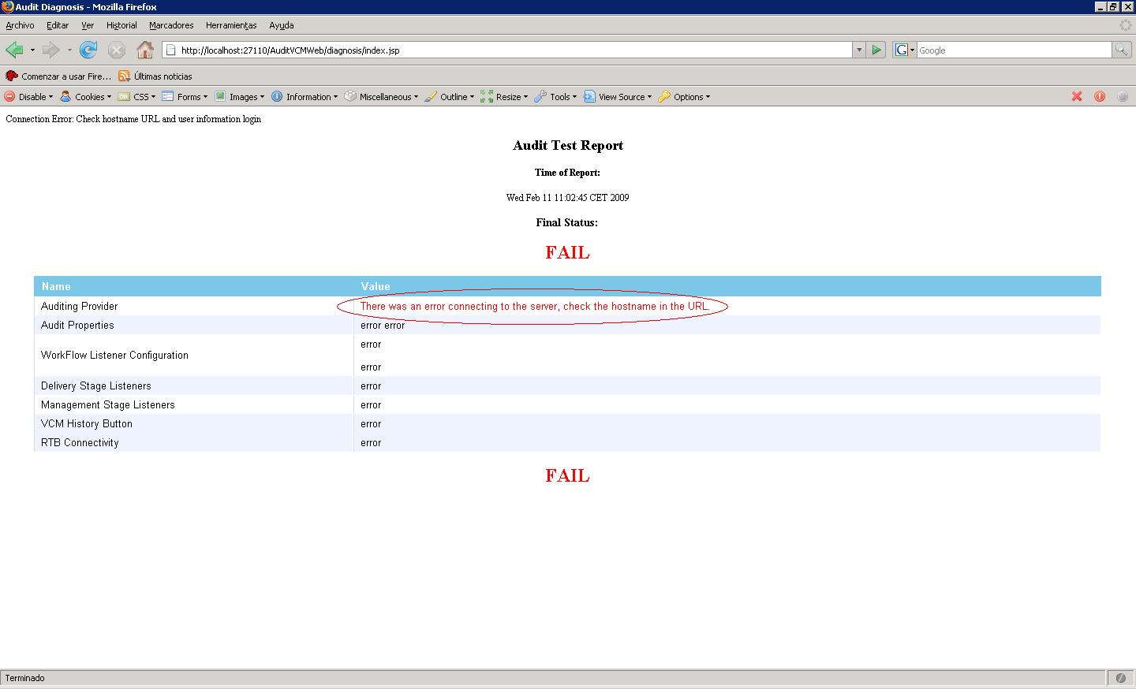

Note: If you experience any errors, please see the Troubleshooting section of this guide.

Update Roles
By default, all the users can see the Audit “Events” button in the Web Experience Management Console and the “Audit” tab in the Content Console, but only the users that have the capability VCM:AUDITOR have the button/tab enabled (please, note that the administrator user (those with VCM:ADMINISTRATOR capability) always has this button enabled). To add this capability to other users, the administrator user of Web Experience Management must modify an existing role to add the capability VCM:AUDITOR, using the next menu option in the management console:

Workbench -> Roles
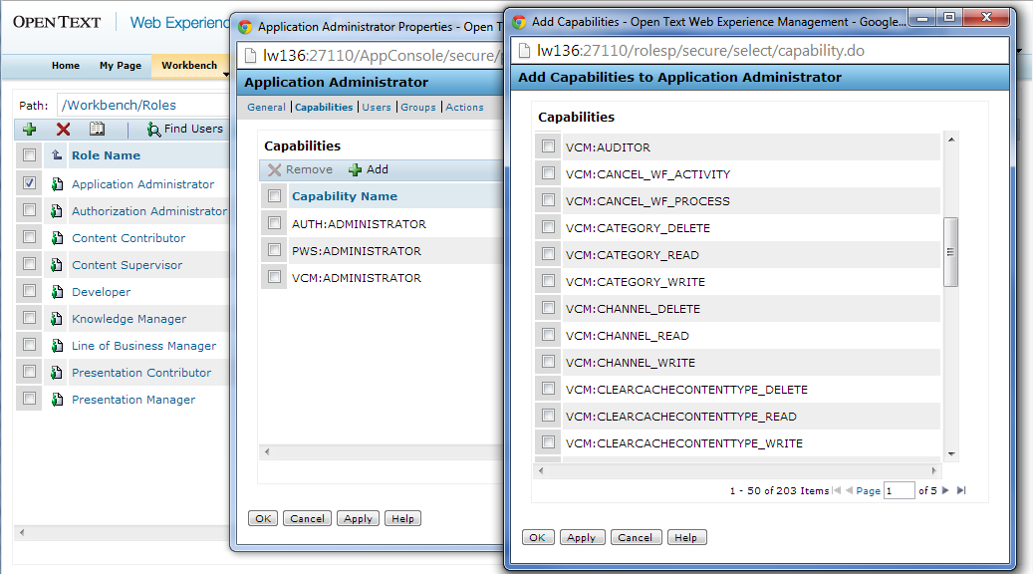
Now, users that have this capability should see “Audit” tab in the Content Workspaces. The following figure shows an example. Please, note that apart from having the capability, the user must belong to any of the groups that are authorized to the Web Experience Management object (channel, site, etc) that the user wants to audit.
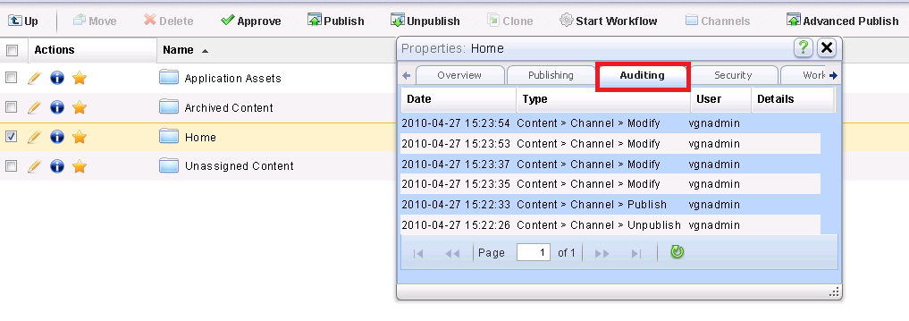

Execute RTB Loader
The utility RTB Loader takes the information stored in the content management system, and loads it in the event database of Web Experience Management Audit. All the Content Instances, Sites, Channels existing in your Web Experience Management Server will generate its creation events, with the respective creation date.

It also accepts filters, and registers events related to the configconsole.
The steps required to execute RTBLoader are:
- You will find RTBloader in <AuditInstallDir>\rtbLoader (i.e.: C:\apps\wem audit\rtbLoader)
- The configuration will be read from the existing Audit’s configuration files.
- Launch script load.bat (or load.sh) from <AuditInstallDir>\rtbLoader.
- Before starting the process, it will ask the password of the administrator user in Web Experience Management
Although the script is configured to fit the typical execution of an initial load, it can be edited to modify one of the following parameters:
load -h host:port -u username -p password -ldapFile ldap.properties [ -g outScript.out | -o [ALL | SI | SF | RL | CH | CV | CI [-type XmlContentTypeName ] ] ]

Property | Description
-h <host:port> | Web Experience Management host and port
-p <password> | Web Experience Management user password
-u <username> | Web Experience Management username
-ldapFile <ldap.properties> | Path to a properties files that contains the following attributes (please note that the installation wizard generates a file with the following parameters adapted to your particular installation, except the password of the principal in LDAP):  groupAttribute=cn(Attribute of groups)  groupObjectClass=groupOfNames  userAttribute=cn(Attribute of users)  userObjectClass=person  ##ALL | group1,group2,group3  allowedGroups=ALL  host=localhost:port  userSearchBase=ou=People,dc=company,dc=es  groupSearchMember=member  #Please provider the password of ldap  adminPassword=password  adminName=cn=admin_name,dc=company,dc=es  groupSearchBase=ou=Groups,dc=company,dc=es
-g <outFileScript.sh> | Generate command-line script with all possible exports. This is very useful in installations with hundreds of thousands of content instances, as the generated script can be split in several smaller scripts that can be launched in parallel to accelerate the event load.
-o <WemObjectType> | Web Experience Management Content Object to export:[ALL|CV|CT|CI|SI|SF|RL] Where  ALL=All object types,  CV=Configuration Values*, CT=Content Types,  CI=Content Instances,  SF=Static Files,  CH=Channels,  SI=Sites,  RL=Roles
-type <XmlNameOfContentType> | Xml name of the content type to load (only with CI)
-interval <maxQueryValue> | Max number of content instances committed in the same operation, [Default 300] (only with CI)
-help | Print a help message
There are two important points to remember:
- If the installation has a really large number of content instances, it is recommended to use the parameter ‘-g outputfileScript’. This is very useful to split the load in several steps (one step to load channels, a step for every content type, etc.).
- If there are custom components in the installation (content types with a java class override), it is important to modify the script load.bat (or load.sh) to add in its classpath the libraries where these classes reside. If you don’t do it, the loader won’t be able to successfully load them.

Upgrade to Web Experience Management Audit Enhanced
You can skip this paragraph if you are not upgrading to Web Experience Management Audit Enhanced. Note that Web Experience Management Audit Enhanced is purchased separately.
If you are installing Web Experience Management Audit Enhanced from scratch, and not updating an existing Web Experience Management Audit installation, please follow the steps beginning at the chapter “Launch Installation Wizard”.

If you want to upgrade a preexisting Web Experience Management Audit, perform the following steps:
- Extract the file bin/rtbserver/management.war from the Web Experience Management Content Audit Enhanced distribution file (i.e. VCM Audit Enhanced.zip) to <AuditInstallDir>\webapps
- Deploy management.war using the runtime services console (http://<VCMhostname>:port/console): Left panel -> Deployments -> Install (Right Panel).
- Test the installation conform to the instructions in the chapter; “Testing the Environment”

Installation on a Web Experience Management Cluster
If you are going to install Web Experience Management Audit in a Web Experience Management cluster with several nodes, you must launch the installation wizard in each one of its machines. You must start with the installations on every Secondary node, and only then proceed to the Primary node.

Installation on Secondary Nodes
When the installer is launched, it will require you to choose the type of installation. Choose the option 2, Installation in a secondary node of a Web Experience Management Cluster. Once the installation is finished for every secondary node, you must proceed with the installation on the Primary node.

Installation on Primary Node
When the installer prompts for the installation type, choose the option 1, Installation on a Primary node of a Web Experience Management cluster.

Then, the steps on Chapter 2 - Installation, must be followed.

Upgrading to Web Experience Management Audit 10.5
Information to assist you with upgrading from Audit 7.6 to Audit 10.5.

How to Upgrade
If you already have a working copy of Vignette Content Audit 7.6 and you have upgraded from Vignette Content 7.6 or Vignette Content 8.0 or 8.0.1 or Web Experience Management 8.1 or 8.5 to Web Experience Management 10.5, you must upgrade to Web Experience Management Audit 10.5.

To do so, proceed with the following steps:
- Make a backup of your Vignette Content Audit Database, following the instructions from your provider.
- Launch the uninstaller for your current Vignette Content Audit 7.6, 8.0, 8.1 or 8.5. Follow the instructions in Uninstalling Web Experience Management Audit.
- Launch the SQL script located under config/dataModel/<DB_VENDOR>/migration/from_7_6.sql
- Launch the Web Experience Management Audit 10.5 installer, following Installation. As the database already exists, the installer won’t touch it and the application will be upgraded without you losing any data.

Uninstalling Web Experience Management Audit
Information to assist you with uninstalling Web Experience Management Audit.

Launch Uninstall Wizard
Under the root of Web Experience Management Audit folder, the installer creates a folder named uninstaller. This folder contains the uninstaller scripts:
- uninstall.sh for UNIX
- uninstall.bat for Windows
Before launching the uninstaller be sure that you are using java 1.6, and JAVA_HOME/bin is at system path. You can use <WEMinstallDir>/Content/10_5/java dir as your Java installation. To launch the script execute uninstall.* file.
For Unix:
$chmod u+x uninstall.sh
$./uninstall.sh

For Windows:
>uninstall.bat

The uninstaller seeks for the necessary information for the uninstall process. If you have installed Web Experience Management Audit in Delivery Stages in remote machines, you must run the uninstaller in each one of them.

==========================================
Welcome to the Web Experience Management Audit uninstall Wizard
The following processes must be running before proceeding:
VgnVCMServer, VgnAdminServer and Config Agents.
==========================================

------------------------------------------
Web applications uninstallation
------------------------------------------
In the next step the following components will be uninstalled:
- Web Experience Management Audit application.
- Web Experience Management Audit Data Collector application.
- Start Parameters.
-Open Text Insights application.
-Pools and Datasources.

Do you want to continue? (yes - continue / no - go back)
>Default value [yes]
>Value:
[yes]

Please provide information for the connection to runtime services (VgnAdminServer)
------------------------------------------
Admin Server Host
>Default value [rtbtests]
>Value:
[rtbtests]

Admin Port
>Default value [27001]
>Value:
[27001]

Admin User
>Default value [vgnadmin]
>Value:
[vgnadmin]

Admin User Password

Do you want to continue? (yes - continue / no - go back)
>Default value [yes]
>Value:
[yes]

Uninstalling ....
Removing connection pool ...
-->Connection pool removed.
Removing start parameters ...
-->Start parameters removed.

Uninstalling Web Experience Management Audit App ...
-----------------------------------------------
-----------------------------------------------
--> Web Experience Management Audit App Uninstalled.

Uninstalling Collector App ...
-----------------------------------------------
-----------------------------------------------
-->Uninstall Collector App Uninstalled.

Uninstalling Open Text Insights ...
-----------------------------------------------
-----------------------------------------------
-->Uninstall Open Text Insights Uninstalled.
done.

------------------------------------------
Web Experience Management configuration
------------------------------------------
In the next step the following components will be uninstalled:
-Workflow listeners.
-Audit libraries.
- Web Experience Management Audit property sheet.
-Audit generic resource.
-Deployment Agent parameters.
- History Button.
- Web Experience Management Automatic Task.

Do you want to continue? (yes - continue / no - go back)
>Default value [yes]
>Value:
[yes]

Please type Web Experience Management (VgnVCMServer) connection info.
------------------------------------------
Web Experience Management Server Host
>Default value [rtbtests]
>Value:
[rtbtests]

Web Experience Management Port
>Default value [27110]
>Value:
[27110]

Admin User
>Default value [vgnadmin]
>Value:
[vgnadmin]

Admin User Password

Do you want to continue? (yes - continue / no - go back)
>Default value [yes]
>Value:
[yes]

Uninstalling ....
Removing data from Deployment Agents ...
-->Deployment Agents data removed.
Removing generic resource ...
-->Generic resource removed.
Removing workflow listener ...
-->workflow listener removed.
Removing buttons ...
-->Buttons removed.
Removing audit property sheet …
-->Audit property sheet removed.
Committing changes ...
Doing deploy (configp) ...

##The next step requires the execution of configp

*** WARNING: Before proceed, check that Runtime Services configuration is not locked in any browser ***

Please press any key

This action may take several minutes, please wait
->Deploy (configp) finished.
Removing Audit program task definition ...
-->Audit program task definition removed.
done.

------------------------------------------
Web Experience Management Audit Database
------------------------------------------
In the next step the following components will be uninstalled:
-Auditor capability.
Do you want to continue? (yes - continue / no - go back)
>Default value [yes]
>Value:
[yes]

Web Experience Management database user information
------------------------------------------
Please provide the parameters needed for connecting to Web Experience Management system database user.

Database software
(Select one option [insert option number])
1)Oracle
2)MSSQL
2

Database Host
>Default value [localhost]
>Value:
[localhost]

Database Port
>Default value [1433]
>Value:
[1433]

Database Instance Name
>Default value [VCMMGMT]
>Value:
[VCMMGMT]

Database User
>Default value [vcmmgmt]
>Value:
[vcmmgmt]

Database User Password

Do you want to continue? (yes - continue / no - go back)
>Default value [yes]
>Value:
[yes]

Uninstalling ....
Removing auditor capability ...
-->Capability removed.
done.

------------------------------------------
Directory structure
------------------------------------------
In the next step the following components will be uninstalled:
-Uninstaller binaries.
- Web Experience Management Audit Applications files.
- Web Experience Management Audit libraries files.
-Folder structure.
-Audit properties files.

Do you want to continue? (yes - continue / no - go back)
>Default value [yes]
>Value:
[yes]

Uninstalling ....

##To continue the process it is necessary stop: VgnVCMServer, VgnAdminServer and all Deployments and Configuration Agents (Some Web Experience Management Audit libraries are going to be removed now; these libraries may be used in other process actually.) . Please stop the server(s) manually and do not close this wizard.
Did the server(s) complete the stop?
>Default value [no]
>Value: yes

Removing libraries ...
-->Libraries removed.
Removing properties ..
-->Properties removed.
Removing applications ..
-->Aplications removed.
Removing folders
-->Folders removed.
done.

The uninstallation process has finished successfully. Please remove Web Experience Management Audit folder manually and start all servers and Config / Deployments Agents.

WARNING: This uninstallation process does not remove the database schema of Web Experience Management Audit, so that you don't lose your data. If you need to remove this database schema, please do it manually.

Please press any key

Final Steps
To completely remove Web Experience Management Audit you will need to complete the following manual steps.

- Remove the Web Experience Management Audit folder
Delete the information stored in the Web Experience Management Audit database. After performing this step you will lose all the historic information. Don’t do it if you plan to upgrade to another version keeping existing events.

Uninstalling from a Web Experience Management Cluster
If the product is installed on a Web Experience Management cluster with several nodes, the uninstaller wizard must be launched at each node.

You must start launching it in the primary node of the cluster (VgnVCMServer), following the steps from Section 4.1, Launching the Uninstall Wizard.

Once that wizard has finished, you can proceed with uninstalling it in the secondary nodes.

Appendix 1 – Troubleshooting
The setup process generates a running installation of Web Experience Management Audit; in case of problems, the following sections describe how to manually install or uninstall some of the components of Web Experience Management Audit. This can be helpful if some of the tests included in Audit fail or the installer failed to perform some specific action.

Please note that all the following steps are usually executed by the setup process, not needing any kind of intervention by the user. The steps are shown here just to document how to perform them manually in case of exceptional scenarios.

Launch Installation Wizard
Before launching the Web Experience Management Audit installer, be sure that you are using Java 1.6. Ensure that JAVA_HOME/bin is at system path. You can use <WEMinstallDir>/Content/10_5/java dir as your Java installation.

Also, it is necessary to have the following processes up and running:
- VgnVCMServer
- VgnAdminServer
- Config Agents

Adding libraries and Classpath manually

Libraries installation in Web Experience Management
To install libraries in Web Experience Management you must copy the following files to the lib directory of OpenText (<WEMinstallDir>/Content/10_5/lib):
- kiron.jar
- json.jar
- rtbclient.jar
- rtbcommon.jar
- AuditVCMLib.jar
- aspectjrt.jar
- aspectjweaver.jar
- backport-util-concurrent.jar

Classpath and Arguments
Web Experience Management Servers must be instructed to use both the libraries and the properties files included with Web Experience Management Audit. Both the Web Experience Management Server and the AppSvcs deployment agents must be configured as follows:

Using the runtime services console, there are two parameters that must be changed:

Classpath: The following libraries must be added at the end of the classpath:
<WEMinstallDir>/Content/10_5/lib/kiron.jar
<WEMinstallDir>/Content/10_5/lib/rtbcommon.jar
<WEMinstallDir>/Content/10_5/lib/rtbclient.jar
<WEMinstallDir>/Content/10_5/lib/log4j.jar
<WEMinstallDir>/Content/10_5/lib/json.jar
<WEMinstallDir>/Content/10_5/lib/aspectjrt.jar

Arguments: The following variables must be added at the end of this parameter.
-DRTBCLIENT-PROPERTIES=<AuditInstallDir>/rtbclient
-DCOLLECTOR-PROPERTIES=<AuditInstallDir>/webapps/collector
-DMANAGEMENT-PROPERTIES=<AuditInstallDir>/webapps/management
-javaagent:<WEMinstallDir>/Content/10_5/lib/aspectjweaver.jar

NOTE: The directory '<AuditInstallDir>' must refer to the exact path where the files are installed.

The following picture shows where to do it:
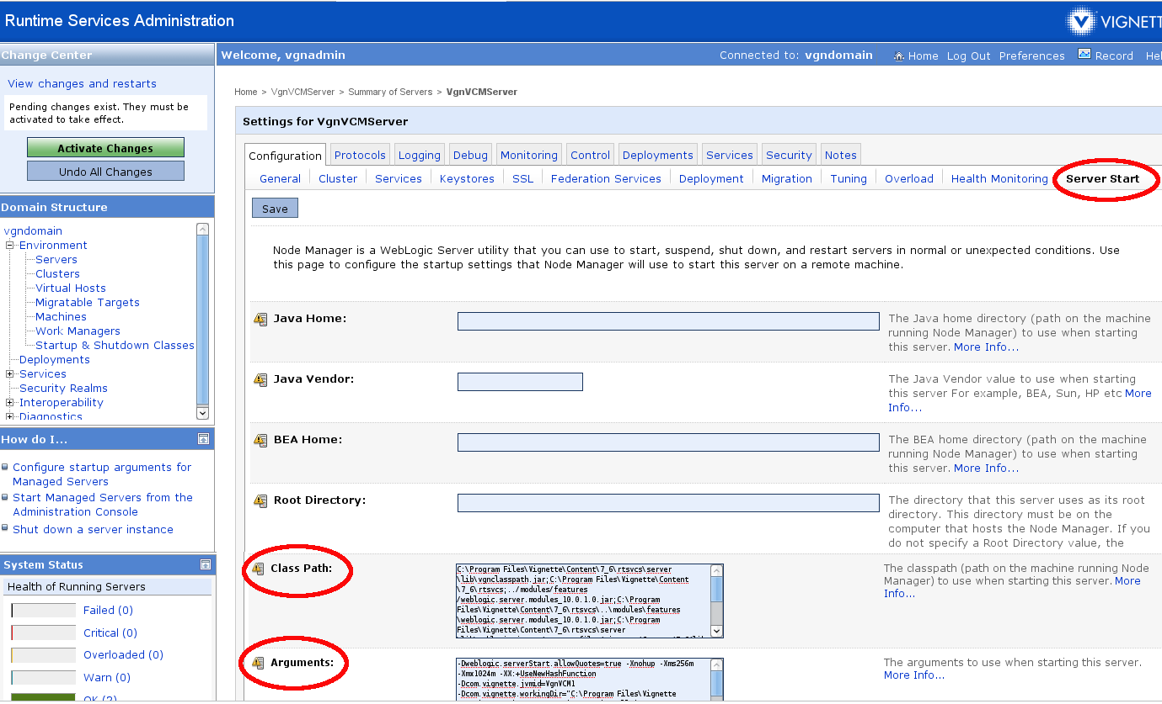

Installation of WF Listener
There is a variable in the Configuration Console that needs to be configured to monitor workflows. In the Configuration Console navigate to the path:
Content->
Management Services->
Management Server
And set:
WF_EVENT_LISTENER_CLASS_NAMES=com.vilt.audit.wf.event.RTBWfEventAudit

Note: This class replaces the default value. Do not append it to the default one.

Deployment of AuditVCMApp
The AuditVCMApp application contains the following utilities:
- Audit diagnosis
- Audit Task for the workflows, a task that allows monitoring of any workflow. For details on how to use it, check Appendix 3.
The application AuditVCMWeb.ear must be configured as any other OpenText extension. The EAR file must be edited, so the libraries thirdparty-combined.jar and vgn-appsvcs-cma.jar are copied inside its folder APP-INF/lib. Besides, the file AuditVCMLib.war included in AuditVCMWeb.ear must be also edited, so the library vgnconfigapp.jar is copied inside its folder WEB-INF/lib. Please use the libraries thirdparty-combined.jar, vgn-appsvcs-cma.jar and vgnconfigapp.jar located in your Web Experience Management installation.

Only after this file is updated with these libraries, it must be deployed in Weblogic.

To deploy this application, is necessary to copy the file AuditVCMApp.ear to a directory of the machine, for example:

/<AuditInstallDir>/webapps/

Then the application can be deployed in Runtime Services, using his console: Deployments → Install

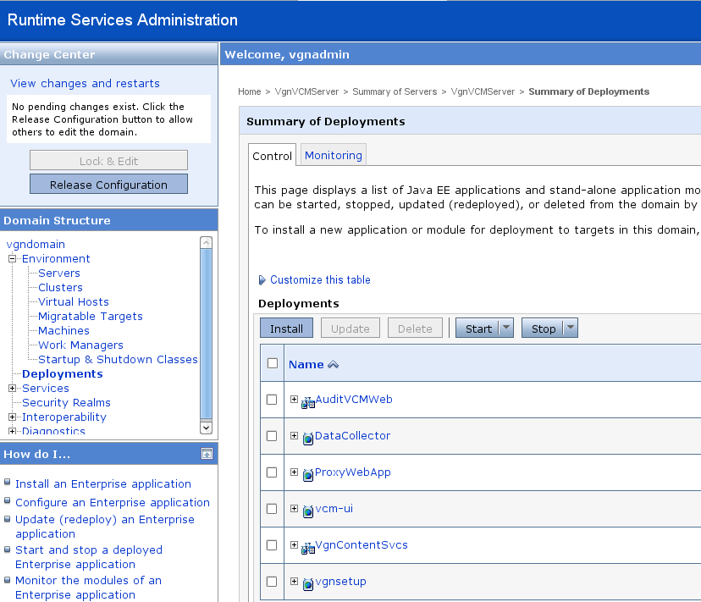

Configuration of Web Experience Management Console “Events” Button, “Events” Tab and “Audit” Tab in the Content Console
This section shows how to configure the Web Experience Management console Events History button.

This web application shows the history of events when a Web Experience Management element is selected (Site, Channel, ContentType, Content Instance, Rol...).

The steps needed to install this application are:
- Add the configuration of the button.
- Add the configuration of the Events tab.
- Add the configuration of the Audit tab (in the Content Console).
- Set the visualization rights for the buttons.

Add the Configuration of the Button
The button that shows the history of events must be properly configured in the Configuration Console. Navigate to:
Content >
Management Services >
Management Console >
Service Provider Framework >
Type Specification Registry >
Customer Extensions Type Specification Registry >
In this location, the next type specifications will be created or modified:

Display Name | Template Name | XML
Content Instance | ContentInstance | config_button_history.xml
Static File | Static File | config_button_history.xml
Root Channel | RootChannel | config_button_history.xml
Site | Site | config_button_history.xml
Content Type | ContentType | config_button_history.xml
Content Instance Association | ContentInstanceAssociation | cia_config_button_history.xml
Static File Association | StaticFileAssociation | cia_config_button_history.xml

The XML field is created by the following procedure:

If the node previously exists in the folder Customer Extensions or System Extension, it must be modified, adding the content of the file config_button_history.xml of cia_config_button_history.xml at the end, just before the tag </service-provider-asset-type-specification>

If the node did not exist in any of those folders, the initial tag will be taken from any other item, and the content of the file config_button_history.xml of cia_config_button_history.xml will be added inside.
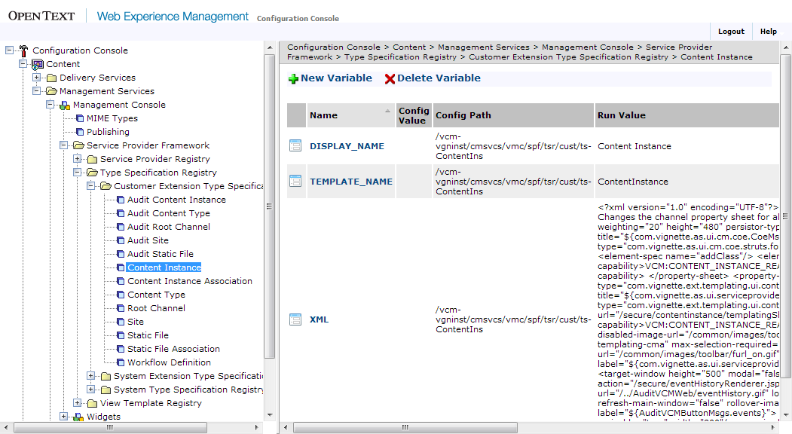

To add the button for watching the history of the roles, the following node must be modified:
Content >
Management Services >
Management Console >
Service Provider Framework >
View Template Registry>
Customer Extensions View Template Registry>
In this location, a new node will be added with the following characteristics:

Display Name | Template Name | XML
Roles | ROLES_TOOLBAR_TEMPLATE | roles_config_button_history.xml

Add the Configuration of the Events Tab
The tab that shows the history of events must be properly configured in the Configuration Console. Navigate to:
Content >
Management Services >
Management Console >
Service Provider Framework >
Type Specification Registry >
Customer Extensions Type Specification Registry >
In this location, you should see the next type specifications:

Display Name | Template Name
Audit Content Instance | AuditContentInstance
Audit Static File | AuditStaticFile
Audit Root Channel | AuditRootChannel
Audit Site | AuditSite
Audit Content Type | AuditContentType

If nodes don’t exist you should run a “vgnimport” to import the “InstallPropertySheet.zip” file that you can find in the Web Experience Management Audit distribution file in the “config/sheet” folder. This import will generate the nodes shown before.

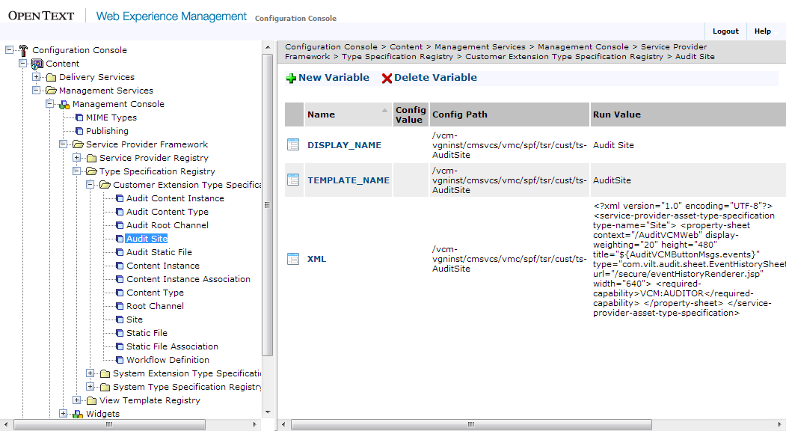

Add the Configuration of the Audit Tab (on Content Console)
This tab shows the history of events in the Content Console.

In order to install it, manually, you should deploy xr_vilt_cc_audit.jar library that you can found in the Web Experience Management Audit distribution file. To do that, you should perform a “configp”.

Visualization Permissions for the Buttons
A new capability must be added in Web Experience Management. The following SQL statement could be used to update the database table of Web Experience Management system schema:
INSERT INTO VGNCAPABILITIES VALUES ('VCM','AUDITOR');
Once the capability has been added, the next step is to modify any existing role to add the capability VCM:AUDITOR, using the next node in the management console:
Workbench -> Roles

Removing Weblogic Auditor
This is not used since this version, so if you have it installed, you should uninstall it. In the Runtime Services Console, just click in Security Realms in the Left Menu, then click in Auditing, and select and delete the Web Experience Management Auditor.
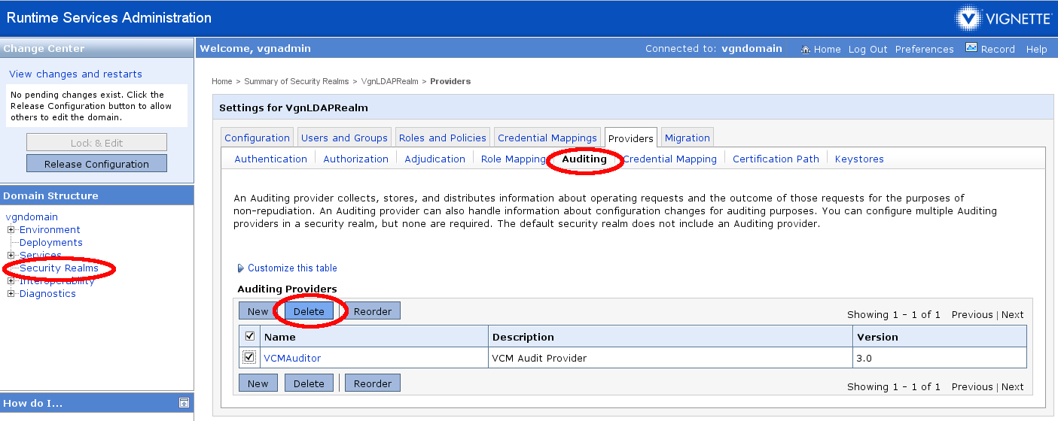

Access Denied to OpenText Insights
If you try to access OpenText Insights (included with Web Experience Management Audit Enhanced) without success, you will receive one of the following error messages:
- ‘Invalid username / password': You have entered a wrong username or password.
- ‘Insufficient privileges’: Your password is OK, but your group is not in the rolemapper section of <AuditInstallDir>\webapps\management.properties. Make sure the LDAP groups and users are correctly spelled, including upper and lower case.
- 'Unable to check your privileges': Audit was wrongly installed, so the LDAP connection is not well configured. Check the LDAP section in <AuditInstallDir>\webapps\management.properties.
Once you have modified the management.properties file, you must stop and redeploy the management web application from the Runtime Services Console. Go to Deployments (left panel), select management application from the list (right panel), stop it, update it and start it.

Restarting the DataCollector in Runtime Services
If you need to restart the DataCollector, you must perform the action ‘update’ instead of stopping and starting, otherwise the classes won’t be reloaded and DataCollector won’t work.

If the application is running and you perform an ‘update’, the application is redeployed and reloaded. If it is stopped, you need to ‘update’ it and then ‘start’ it.

Using TAS
OpenText’s Trusted Authentication Server, TAS, is supported by OpenText Insights, so you can use this tool through it. It is however supported in Web Experience Management Audit, so the event history can be viewed through a preview application server using TAS.

If you want to use TAS with Web Experience Management Audit and OpenText Insights, proceed as follows:
- If TAS is defined as your default web application, there are no additional steps to perform; it should be working out of the box.
- If TAS is not your default web application, you must create an AuditVCMWeb.war and an Insights.war following TAS instructions on how to create a proxy web application, available in the chapter Deploying Extensions for TAS, Appendix D, in Dynamic Portal and Dynamic Site Configuration Guide 10.5.

Appendix 2 – Properties Files
The properties files included in the Web Experience Management Audit 10.5 distribution have this structure:
- <AuditInstallDir>/rtbclient/
  - rtbclient-global.properties
- <AuditInstallDir>/webapps/
  - collector.properties
  - management.properties

IMPORTANT NOTE: In order to work properly, the files must be saved in UTF-8.

Both the password of the LDAP principal user and the password of the Email Account used by Web Experience Management Audit to send mails are obfuscated for enhanced security. In the installation process, the passwords requested to the user are obfuscated; in case of any of this passwords need to be changed in the future, the administrator must use the tool obfuscator.bat/obfuscator.sh to update the properties files. The following picture shows you how to do it.

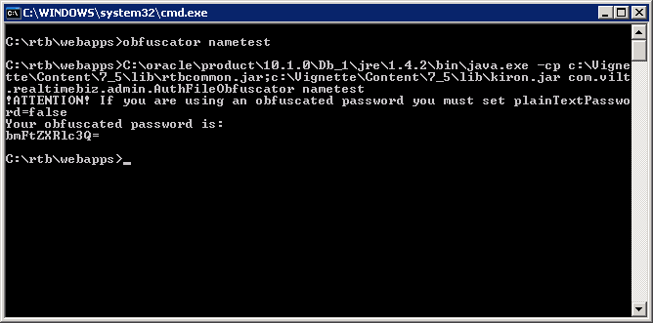

The obfuscated password must be manually copied into the properties files at appropriate location.

Collector Properties (collector.properties)
[main]

#The DataBase vendor: Oracle | MSSQL
DB.type=MSSQL

#This property defines the timeout in milliseconds to keep alive a browser RTB session upon inactivity. It has a default value of 5min. If set to -1 the session will remain alive until it is closed manually.
browserKRouterConnection.timeout=1800000

#Name of the JNDI Data Source to use
DB.poolDataSource=jdbc.RTBMMSQL

#Weblogic conection.The value should be t3://<server>:<port>
java.naming.provider.url=t3://localhost:27110

#Initial Factory for Weblogic pool
java.naming.factory.initial=weblogic.jndi.WLInitialContextFactory

#User that owns the DB schema. This must be set when there are multiple RTB instalations on the same DBMS
#DB.schemaOwner=VILTSITE

#IP range database location
#geolocation=/home/geolocation

#Use plain text password
plainTextPassword=false

#The SMTP host used to send mails
SMTPHost=rtbtests

#The SMTP port used to send mails
SMTPPort=25

#The account used to send mails
emailSenderUsername=rtb@vilt.es

#The account's password
emailSenderPassword=cnRi

#The name that will appear as the sender. This has effect only in MyReports module and represents the email sender name
#emailSenderPersonalName=RTB

[kiron]

[kiron.kpeer]

#This section defines kiron's internal configuration

#Internal configuration, DO NOT CHANGE THIS

connectionType=local
KIP=0

#DataCollector hostname
KRouter.IP=rtbtests

kvn.attempts=-1

#End of internal configuration

#Internal thread pool size. This pool is used to dispatch event registration. Default size is 10
#remoting.threadPool=10

#Browser client identification cookie lifetime in milliseconds. -1 will last until the user closes the browser
#http.cookie.age=-1

#Maximum time that pool conexion its open
#leaserReaper.timeout=10000

[kiron.krouter]

#DataCollector Kiron listen port
port=26000

[logging]

#This section defines the properties related to the logging system. By default the log levels are set to warning (WARN). If you are having troubles, log levels should be set to DEBUG

#RFile is set to be a FileAppender
log4j.appender.RFile=org.apache.log4j.RollingFileAppender

#RFile maximum sixe
log4j.appender.RFile.MaxFileSize=1000KB

#RFile max backup index
log4j.appender.RFile.MaxBackupIndex=10

#RFile log file
log4j.appender.RFile.File=c:/program files/vcm audit/logs/rtbcollector.log

#RFile layout. RFile uses PatternLayout
log4j.appender.RFile.layout=org.apache.log4j.PatternLayout

#RFile ConversionPattern
log4j.appender.RFile.layout.ConversionPattern=%d [%t] %-5p %c{2} %x - %m%n

#package com.vilt.kiron. Set it to DEBUG level to get details about the underlying communication layer
log4j.logger.com.vilt.kiron=WARN, RFile

#package com.vilt.realtimebiz. Set it to DEBUG level to get details about the handling of events
log4j.logger.com.vilt.realtimebiz=WARN, RFile

#Interceptors package. Set it to DEBUG level to get details on VCM Audit's interceptors included in collector
log4j.logger.com.vilt.audit.interceptors=WARN, RFile

[authentication]

#This section defines the properties related to the authentication
#Class used for authentication

authenticatorClass=com.vilt.realtimebiz.bousers.jndi.JNDIIntegration

#Enables/Disables authentication mechanism, default is enabled
authDisable=0

#Ldap Connection URL
ldapurl=ldap://rtbtests:27110

#LDAP Principal User
adminName=uid=vgnadmin,ou=people,ou=VgnLDAPRealm,dc=vgndomain
groupAttribute=cn

#Principal password
adminPassword=dmlnbmV0dGU=

#Base to search users. Root of LDAP tree where to begin the user lookup.
searchBase=ou=people,ou=VgnLDAPRealm,dc=vgndomain

#Base to search groups
groupSearchBase=ou=groups,ou=VgnLDAPRealm,dc=vgndomain

#Group class property
groupObjectClass=groupOfUniqueNames

#User group property
groupSearchMember=uniqueMember

#If true, will use complete user DN for authentication, otherwise the username is used. Must be true in some LDAP implementations
principal.useDN=true

#Use DIGEST-MD5 for LDAP user authentication, default disabled
#java.naming.security.authentication=DIGEST-MD5

#User identification property
userResolver=uid

#User object class
userObjectClass=inetOrgPerson

#Use plain text password. Default true
plainTextPassword=false

[rolemapper]

#This section defines the rolemapper's properties
#Role mapping in file system (default)
rolemapperClass=com.vilt.realtimebiz.bousers.SimpleFileRoleMapper

#These properties define the AD attributes to use in role mapping. If you are using the user fully qualified name to map roles you don't need this. Just keep your properties as they are
#attributeNames=memberOf distinguishedName

#Role enumeration. Specify all needed roles
applicationRoles=Audit Admin xml_viewer scheduling VCM
role.scheduling=cn=Administrators,ou=groups,ou=VgnLDAPRealm,dc=vgndomain
role.Audit=cn=Administrators,ou=groups,ou=VgnLDAPRealm,dc=vgndomain
role.Admin=cn=Administrators,ou=groups,ou=VgnLDAPRealm,dc=vgndomain
role.VCM=cn=Administrators,ou=groups,ou=VgnLDAPRealm,dc=vgndomain
role.xml_viewer=cn=Administrators,ou=groups,ou=VgnLDAPRealm,dc=vgndomain

[support]

#This section is used to define the properties for the log sending facilities

#The location of the log file
files=c:/program files/vcm audit/logs/rtbcollector.log

#The name that will appear as the sender
emailSenderPersonalName=RTB

#Destination mails, comma-separated
SendTo=admin@vilt.es

OpenText Insights Properties (management.properties)
[main]

#The limit of search pages for file exports, each page has 10 results. Default is 30. e.g. 50 = 500 results will be exported to file
searchExportPageLimit=50

#The DataBase vendor: Oracle | MSSQL
DB.type=MSSQL

#Name of the JNDI Data Source to use
DB.poolDataSource=jdbc.RTBMMSQL

#Enables/Disables facts, default is false
facts.enabled=false

#Weblogic conection
java.naming.provider.url=t3://rtbtests:27110

#Enables/Disables property value caching, default is disabled
propertyValueCache=disabled

#If enabled will return null in case of a PV Cache miss. If disabled it will not populate the cache. Default is enabled.
propertyValueReturnCacheOnly=enabled

#Initial Factory for Weblogic pool
java.naming.factory.initial=weblogic.jndi.WLInitialContextFactory

#If enabled will build the PV cache when the server starts up. Default is disabled
propertyValueCacheStartup=disabled

#User that owns the DB schema. This must be set when there are multiple RTB instalations on the same DBMS
#DB.schemaOwner=VILTSITE

#IP range database location
#geolocation=/home/geolocation

#Use plain text password
plainTextPassword=false

#The SMTP host used to send mails
SMTPHost=rtbtests

#The SMTP port used to send mails
SMTPPort=25

#The account used to send mails
emailSenderUsername=rtb@vilt.es

#The account's password
emailSenderPassword=cnRi

#The name that will appear as the sender
#emailSenderPersonalName=RTB

[kiron]

[kiron.kpeer]

#This section defines kiron's internal configuration
#Internal configuration, DO NOT CHANGE THIS

connectionType=local
KIP=0

#End of internal configuration

#DataCollector hostname
KRouter.IP=rtbtests

#Cookie name
cookieName=managementKIP

#This property defines the timeout in milliseconds to keep alive a browser RTB session upon inactivity. It has a default value of 5min. If set to -1 the session will remain alive until the browser is closed
browserKRouterConnection.timeout=-1

[kiron.krouter]

#DataCollector Kiron listen port
port=26099

[logging]

#This section defines the properties related to the logging system. By default the log levels are set to warning (WARN). If you are having troubles, log levels should be set to DEBUG

#RFile is set to be a FileAppender
log4j.appender.RFile=org.apache.log4j.RollingFileAppender

#RFile maximum sixe
log4j.appender.RFile.MaxFileSize=1000KB

#RFile max backup index
log4j.appender.RFile.MaxBackupIndex=10

#RFile log file
log4j.appender.RFile.File=c:/program files/vcm audit/logs/rtbmanagement.log

#RFile layout. RFile uses PatternLayout
log4j.appender.RFile.layout=org.apache.log4j.PatternLayout

#RFile ConversionPattern
log4j.appender.RFile.layout.ConversionPattern=%d [%t] %-5p %c{2} %x - %m%n

#package com.vilt.kiron. Set it to DEBUG level to get details about the underlying communication layer
log4j.logger.com.vilt.kiron=WARN, RFile

#package com.vilt.realtimebiz. Set it to DEBUG level to get details about the handling of events
log4j.logger.com.vilt.realtimebiz=WARN, RFile

[authentication]

#This section defines the properties related to the authentication
#Class used for authentication

authenticatorClass=com.vilt.realtimebiz.bousers.jndi.JNDIIntegration

authDisable=0

#Ldap Connection URL
ldapurl=ldap://rtbtests:27110

#LDAP Principal User
adminName=uid=vgnadmin,ou=people,ou=VgnLDAPRealm,dc=vgndomain

groupAttribute=cn

#Principal password
adminPassword=dmlnbmV0dGU=

#Base to search users
searchBase=ou=people,ou=VgnLDAPRealm,dc=vgndomain

#Base to search groups
groupSearchBase=ou=groups,ou=VgnLDAPRealm,dc=vgndomain

#Group class property
groupObjectClass=groupOfUniqueNames

#User group property
groupSearchMember=uniqueMember

#If true, will use complete user DN for authentication, otherwise the username is used. Must be true in some LDAP implementations
principal.useDN=true

#Use DIGEST-MD5 for LDAP user authentication, default disabled
#java.naming.security.authentication=DIGEST-MD5

#User identification property
userResolver=uid

#User object class
userObjectClass=inetOrgPerson

#Use plain text password. Default true
plainTextPassword=false

[rolemapper]

#This section defines the rolemapper's properties
#Role mapping in file system (default)

rolemapperClass=com.vilt.realtimebiz.bousers.SimpleFileRoleMapper

#These properties define the AD attributes to use in role mapping. If you are using the user fully qualified name to map roles you don't need this. Just keep your properties as they are
#attributeNames=memberOf distinguishedName

#Role enumeration. Specify all needed roles
applicationRoles=Audit Admin xml_viewer scheduling VCM

role.scheduling=cn=Administrators,ou=groups,ou=VgnLDAPRealm,dc=vgndomain
role.Audit=cn=Administrators,ou=groups,ou=VgnLDAPRealm,dc=vgndomain
role.Admin=cn=Administrators,ou=groups,ou=VgnLDAPRealm,dc=vgndomain
role.VCM=cn=Administrators,ou=groups,ou=VgnLDAPRealm,dc=vgndomain
role.xml_viewer=cn=Administrators,ou=groups,ou=VgnLDAPRealm,dc=vgndomain

[scheduling]

#This section defines the scheduling properties

#cron format: seconds, minutes, hours, day of month, month, day of week, (year)
#0 0 12 * * ? Fire at 12pm (noon) every day
#0 15 10 ? * * Fire at 10:15am every day
#0 15 10 * * ? Fire at 10:15am every day
#0 15 10 * * ? * Fire at 10:15am every day
#0 15 10 * * ? 2005 Fire at 10:15am every day during the year 2005
#0 * 14 * * ? Fire every minute starting at 2pm and ending at 2:59pm, every day
#0 0/5 14 * * ? Fire every 5 minutes starting at 2pm and ending at 2:55pm, every day
#0 0/5 14,18 * * ? Fire every 5 minutes starting at 2pm and ending at 2:55pm, AND fire every 5 minutes starting at 6pm and ending at 6:55pm, every day
#0 0-5 14 * * ? Fire every minute starting at 2pm and ending at 2:05pm, every day
#0 10,44 14 ? 3 WED Fire at 2:10pm and at 2:44pm every Wednesday in the month of March.
#0 15 10 ? * MON-FRI Fire at 10:15am every Monday, Tuesday, Wednesday, Thursday and Friday
#0 15 10 15 * ? Fire at 10:15am on the 15th day of every month
#0 15 10 L * ? Fire at 10:15am on the last day of every month
#0 15 10 ? * 6L Fire at 10:15am on the last Friday of every month
#0 15 10 ? * 6L Fire at 10:15am on the last Friday of every month
#0 15 10 ? * 6L 2002-2005 Fire at 10:15am on every last friday of every month during the years 2002, 2003, 2004 and 2005
#0 15 10 ? * 6#3 Fire at 10:15am on the third Friday of every month
#0 0 12 1/5 * ? Fire at 12pm (noon) every 5 days every month, starting on the first day of the month.
#0 11 11 11 11 ? Fire every November 11th at 11:11am.

crons=SegmentUpdater,PropertyValueUpdater,EventLifetime,PropertyValueCacheReloader

#segment updater schedule class
SegmentUpdater.class=com.vilt.realtimebiz.scheduling.SegmentUpdaterJob

#segment updater schedule class
SegmentUpdater.cron=0 0 01 1/5 * ?

#Property value updater class
PropertyValueUpdater.class=com.vilt.realtimebiz.scheduling.PropertyValueUpdaterJob

#Property value updater class
PropertyValueUpdater.cron=0 0 02 * * ?

#Event lifetime class. This task is used to remove events older than its associated lifetime
EventLifetime.class=com.vilt.realtimebiz.scheduling.EventLifetimeJob

#Event lifetime class. This task is used to remove events older than its associated lifetime
EventLifetime.cron=0 0 0 1/5 * ?

#ManagementConsole cache job
PropertyValueCacheReloader.class=com.vilt.realtimebiz.reporting.PropertyValueCacheReloaderJob

#ManagementConsole cache job
PropertyValueCacheReloader.cron=0 0 03 * * ?

[scheduling.quartz]

#Quartz scheduler internal configuration. Please do not modify this

org.quartz.scheduler.instanceName=Sched1
org.quartz.scheduler.instanceId=1
org.quartz.scheduler.rmi.export=false
org.quartz.scheduler.rmi.proxy=false
org.quartz.threadPool.class=org.quartz.simpl.SimpleThreadPool
org.quartz.threadPool.threadCount=3
org.quartz.jobStore.class=org.quartz.simpl.RAMJobStore

#End of quartz internal configuration

[support]

#This section is used to define the properties for the log sending facilities
#The location of the log file

files=c:/program files/vcm audit/logs/rtbmanagement.log

#The name that will appear as the sender
emailSenderPersonalName=RTB

#Destination mails, comma-separated
SendTo=admin@vilt.es

Client Properties (rtbclient-global.properties)
[kiron]

[kiron.kpeer]

#This section defines kiron's internal configuration

#Internal configuration, DO NOT CHANGE THIS

connectionType=tcp
KIP=VDHCP

#End of internal configuration

#DataCollector hostname
KRouter.IP=rtbtests

#DataCollector listen port
KRouter.port=26000

#Timeout in milliseconds to wait for remote method invocation acknowledge. If -1, will wait forever until remote method invocation returns. Default value is 5s
remoting.timeout=5000

#If true RtbClient will automatically reconnect to DataCollector on connection failure. Default value is true
tcp.autoReconnect=true

#Internal configuration, DO NOT CHANGE THIS

kvn.timeout=5000
kvn.autoReconnect=true
kvn.attempts=15

#End of internal configuration

[rtbclient]

#This section defines the configuration of rtbclient

#If true, client will wait until RtbClient connects to DataCollector
waitForConnection=true

#Enable/Disable RtbClient. Enabled by default
#rtbclient.enable=true

#Timeoutto wait for DataCollector connection in milliseconds
waitForConnectionTimeout=60000

#If true, RtbClient will register events even if user HttpServletRequest does not have cookies. True by default
#rtbclient.no_cookies=true

[logging]

#This section defines the properties related to the logging system. By default the log levels are set to warning (WARN). If you are having troubles, log levels should be set to DEBUG

#RFile is set to be a FileAppender
log4j.appender.RFile=org.apache.log4j.RollingFileAppender

#RFile maximum sixe
log4j.appender.RFile.MaxFileSize=1000KB

#RFile max backup index
log4j.appender.RFile.MaxBackupIndex=10

#RFile log file
log4j.appender.RFile.File=c:/program files/vcm audit/logs/rtbclient.log

#RFile layout. RFile uses PatternLayout
log4j.appender.RFile.layout=org.apache.log4j.PatternLayout

#RFile ConversionPattern
log4j.appender.RFile.layout.ConversionPattern=%d [%t] %-5p %c{2} %x - %m%n

#package com.vilt.kiron. Set it to DEBUG level to get details about the underlying communication layer
log4j.logger.com.vilt.kiron=WARN, RFile

#package com.vilt.realtimebiz. Set it to DEBUG level to get details about the handling of events
log4j.logger.com.vilt.realtimebiz=WARN, RFile

#file2 is set to be a FileAppender
log4j.appender.file2=org.apache.log4j.RollingFileAppender

#file2 maximum size.
log4j.appender.file2.MaxFileSize=10000KB

#file2 MaxBackupIndex
log4j.appender.file2.MaxBackupIndex=10

#file2 log file
log4j.appender.file2.File=c:/program files/vcm audit/logs/rtbVcmAudit.log

#file2 layout. file2 uses PatternLayout
log4j.appender.file2.layout=org.apache.log4j.PatternLayout

#file2 ConversionPattern
log4j.appender.file2.layout.ConversionPattern=%d [%t] (%F:%L) %-5p %c{2} (%x) - %m%n

#package com.vilt.audit.listeners. Set it to DEBUG level to get details on the event listener
log4j.logger.com.vilt.audit.listeners=WARN, file2

#package com.vilt.audit.wf. Set it to DEBUG level to get details on the workflow listener
log4j.logger.com.vilt.audit.wf=WARN, file2

#package com.vilt.audit.utils
log4j.logger.com.vilt.audit.utils=WARN, file2

#package com.vilt.audit.history. Set it to DEBUG level to get details on the event history popup in VCM
log4j.logger.com.vilt.audit.history=WARN, file2

#package com.vilt.audit.weblogic. Set it to DEBUG level to get details on the weblogic auditor
log4j.logger.com.vilt.audit.weblogic=WARN, file2

#file3 is set to be a FileAppender.
log4j.appender.file3=org.apache.log4j.RollingFileAppender

#file3 Maximum size.
log4j.appender.file3.MaxFileSize=10000KB

#file3 MaxBackupIndex
log4j.appender.file3.MaxBackupIndex=10

#file3 log file
log4j.appender.file3.File=c:/program files/vcm audit/logs/rtbLoader.log

#file3 layout
log4j.appender.file3.layout=org.apache.log4j.PatternLayout

#file3 ConversionPattern
log4j.appender.file3.layout.ConversionPattern=%d [%t] (%F:%L) %-5p %c{2} (%x) - %m%n

#RTBLoader log
log4j.logger.com.vilt.audit.load=DEBUG, file3

[support]
#This section is used to define the properties for the log sending facilities
#The location of the log file
files=c:/program files/vcm audit/logs/rtbclient.log

Appendix 3 – Audit Task

About the Audit Task
This workflow automated task is part of a set of tools included at an extensibility package of RTB. Contact your OpenText Sales representative for more information about extensibility capabilities.
AuditTasks is used to log the events generated in the workflows. You need to use it if you want to audit existing custom Workflows whose events are not being registered by the WorkFlow Listener.
When running the installer, the application AuditVCMApp will be automatically installed. It automatically creates a new Program Task Definition named AuditTasks.

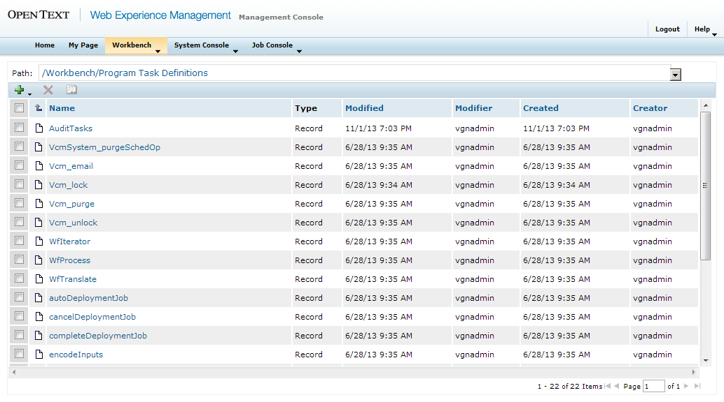

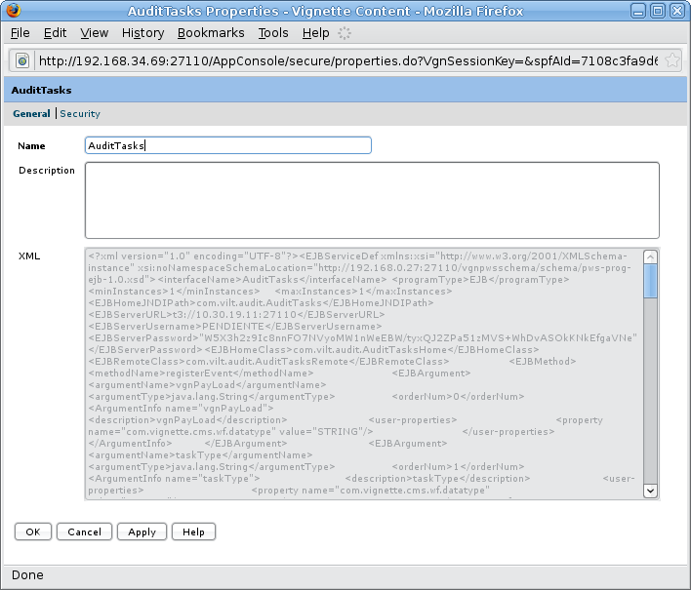

An automatic task named registerEvent is created. You need to place it in specific points of the WorkFlows’s diagrams in order to audit them.

Workflows Update
The custom WorkFlows developed by the costumer can be audited using the program task registerEvent. To use it, it is necessary to add a new automatic task in the workflow diagram. This task receives as input the event name that is going to be audited and its properties as parameters, described in the next section. As shown in the diagram below, the only required change is to add a new split that redirects the exit of the task to be audited to the registerEvent task.

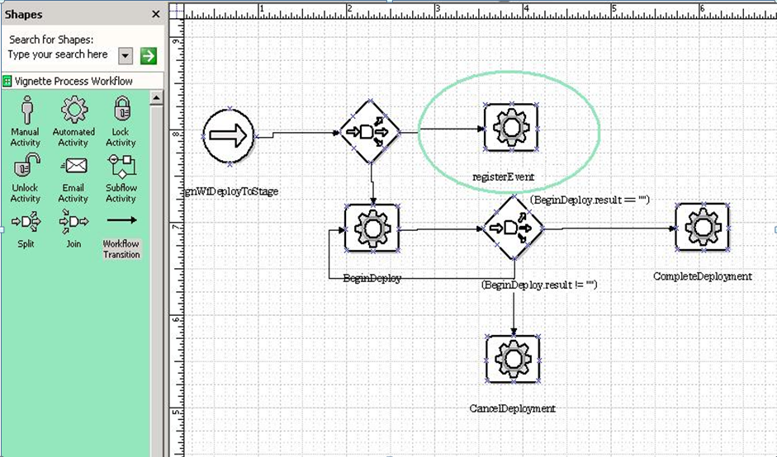

Parameters
The task registerEvent receives the following 16 parameters:
- taskType: Type of the task, that can have the values escalation, manual, or auto, depending on how the user is obtained:
- escalation or manual: The user is obtained from a parameter named user.
- auto: The user is obtained automatically.
- user: Used to define the user when taskType is escalation or manual.
- eventName: Name with which the event will be registered. By default, the event is registered with the following properties:
- taskType
- wf_id

If the task has an associated payload, there will be registered as many events as the contents that the payload has, and there are also added the following attributes:
- vcm_id
- ci_name

Along with these attributes, the attributes defined by the following parameters, with the syntax paramX=valueX, will always try to be registered:
- pBool1
- vBool1
- param1
- value1
- param2
- value2
- param3
- value3
- param4
- value4
- param5
- value5
- result (Not used).

Appendix 4 – Events
The following table shows the complete list of events that Web Experience Management Audit registers. If you want to refer to a branch in a secondary level (for example to filter it), compose its name by appending its path along the branches, without any spaces, like ContentInstanceRead or OperationConfigVarCreate.

Level 1 Branch | Level 2 Branch | Level 3 Branch | Level 4 Branch
Content | Instance | Create, Modify, Delete, Publish, Unpublish, Read
 | Static File | Create, Modify, Delete, Publish, Unpublish, Read
 | Site | Create, Modify, Delete, Publish, Unpublish
 | Channel | Create, Modify, Delete, Publish, Unpublish
 | Type | Create, Modify, Delete, Publish
Operation | Search | Simple, Advanced
 | Login | Success, Failure
 | Config | Commit
 |  | Var | Create, Modify, Delete
 | Role | Create
 |  | Modify | Add Capability, Delete Capability, Add User, Delete User, Add Group, Delete Group
Workflow | Start
 | Complete
 | Terminate
 | Abort
 | Activity | Start, Complete, Terminate, Abort, Accept, Decline
 | *Job | Publish, Unpublish

*Note: WorkflowJob cannot be filtered except if eventsDisabled=ALL, as it is a system event.

Contact Information
OpenText Corporation
275 Frank Tompa Drive
Waterloo, Ontario
Canada, N2L 0A1

Email: support@opentext.com
Knowledge Center: https://knowledge.opentext.com

For more information, visit www.opentext.com

